Garden Frolic

- Red Glider, Cymothoe sangris, Africa
- Red Spotted Purple Admiral, Lmenitis athemis astyanax, N. America
- Hystapes 88, Callicore hystapes, Peru
- Monarch Butterfly, Danaus plexippus, S. America
- Blue-Orange Asterope, Markii davisi, Peru
- The Postman Butterfly, Heliconius melpomeme amaryllis, Peru
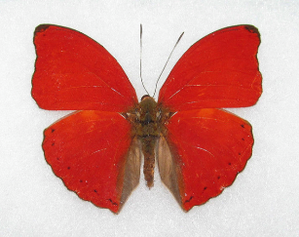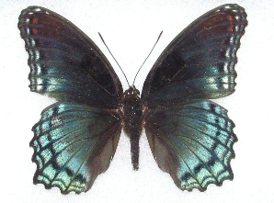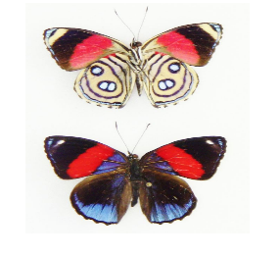
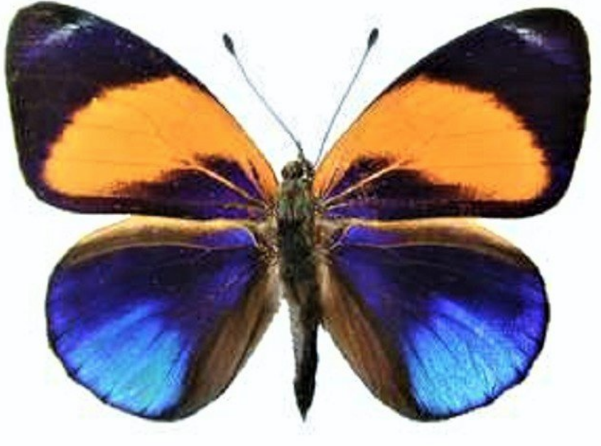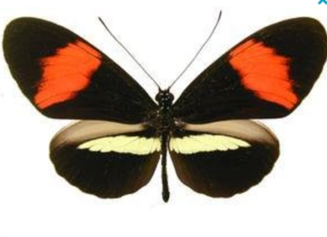

Chaos Theory

- White Witch Moth, Thysania aggrippina, Peru
- Blue Morpho Wings, Peru
- Featured collected butterfly wings from
Owl Butterfly, Caligo brasilensis, Columbia

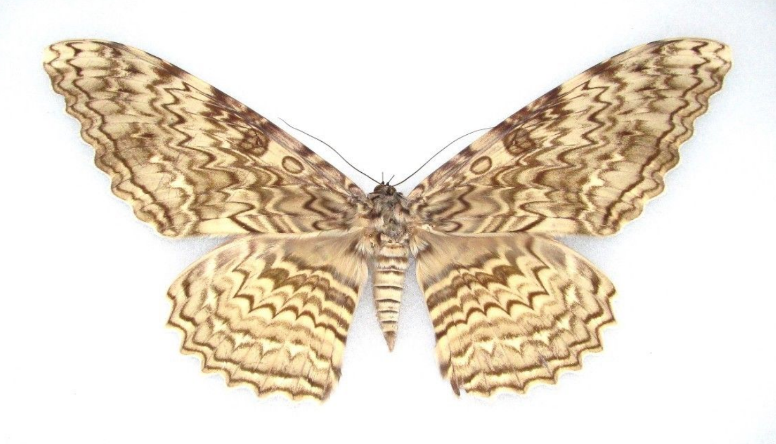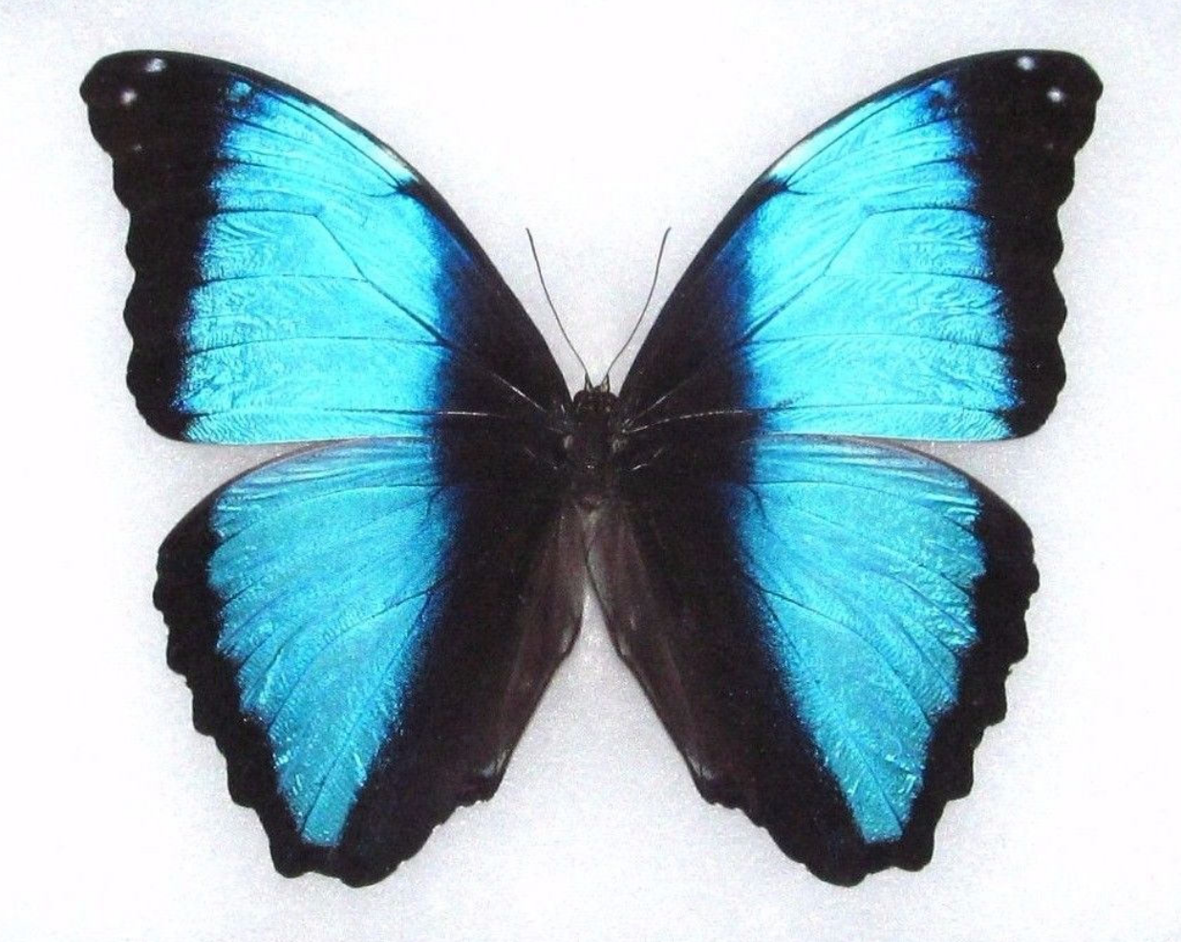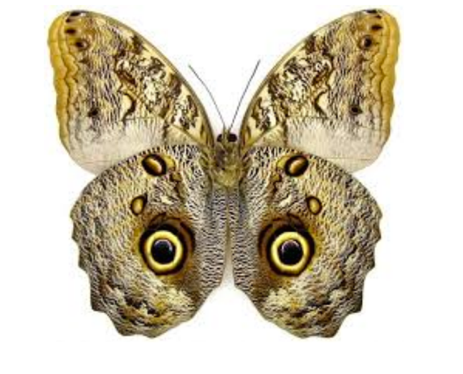

Clear Winged Midnight

- Glass Clear Wing, Thyridia ithomiidae, S. America

Featuring wings from Wallace’s Golden Birdwing, Ornithoptera urvillanus, Indonesia
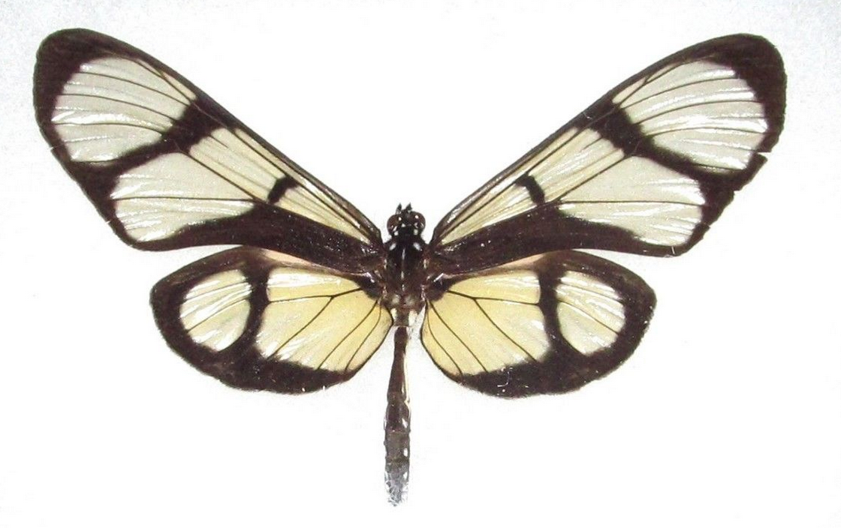
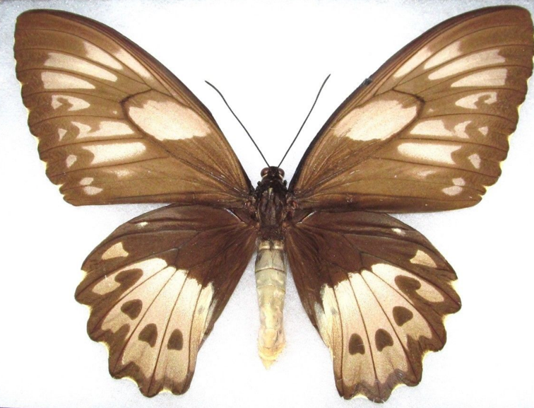
Victorian Butterfly Tea

- Black & White Rice Paper, Idea leuconoe Indonesia
- Scarlet Leafwing, Siderone nemesis, El Salvador

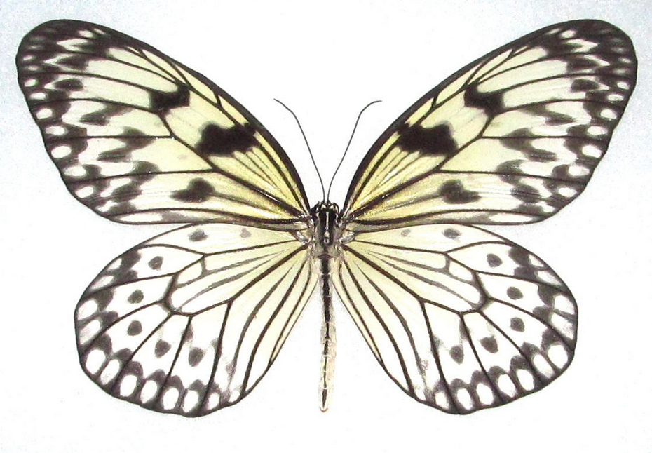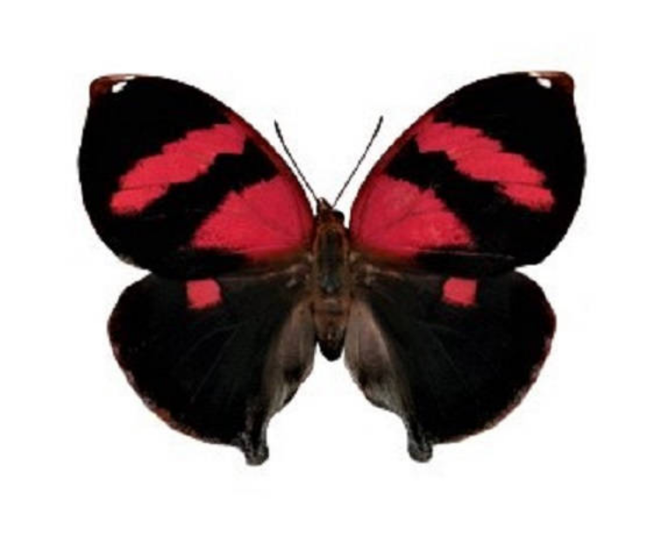

Gypsy Caravan

- Giant Silk Moth, Argema mittrei comet, Madagascar
- Pink-Yellow Saturn Moth, Aurivillius saturniidae, Africa
- Pink Saturn Moth, Costa Rica
- Saturn Moth, Sphingicampa, N. America

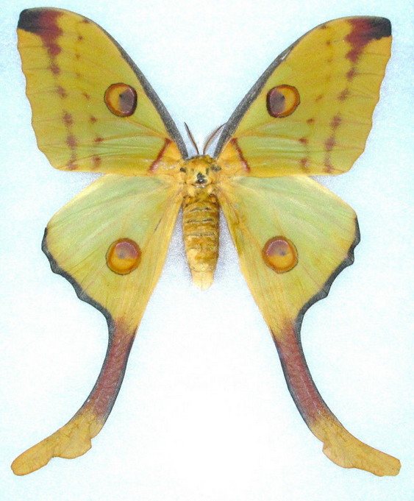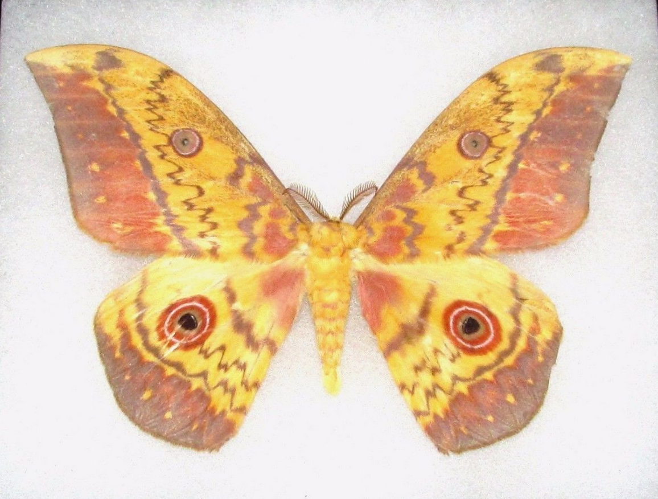
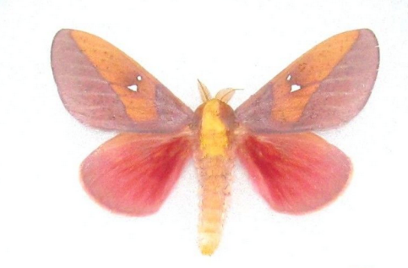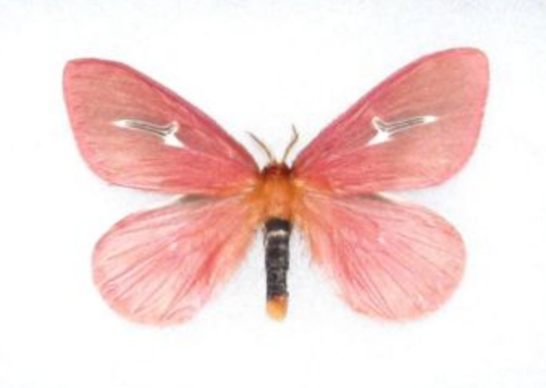

Sunset Morpho & Starry Nights

- Blue Morpho Tingo Maria, Morpho deidamia, Peru
- Blue Starry Night, Hamadryas laodamia, Peru

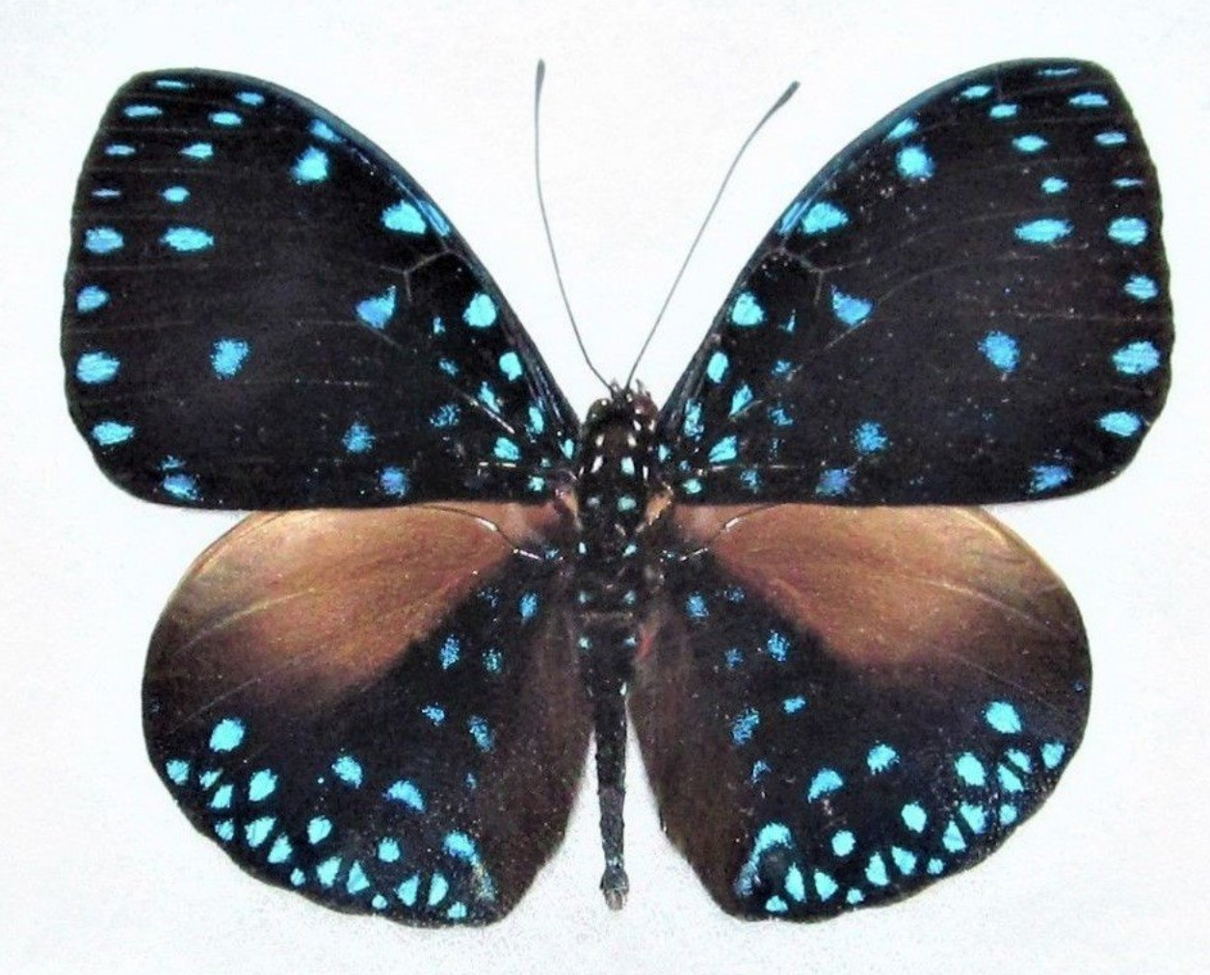

Luna

- Luna Moth, Actius luna, N. America

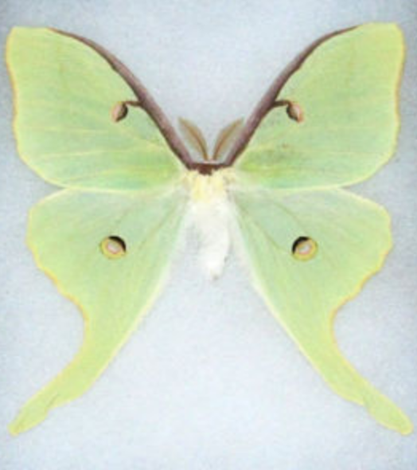

Emergence

- Malachite Verso, Metamorpha stelenes, Peru
- Pale Green Eupale, Africa

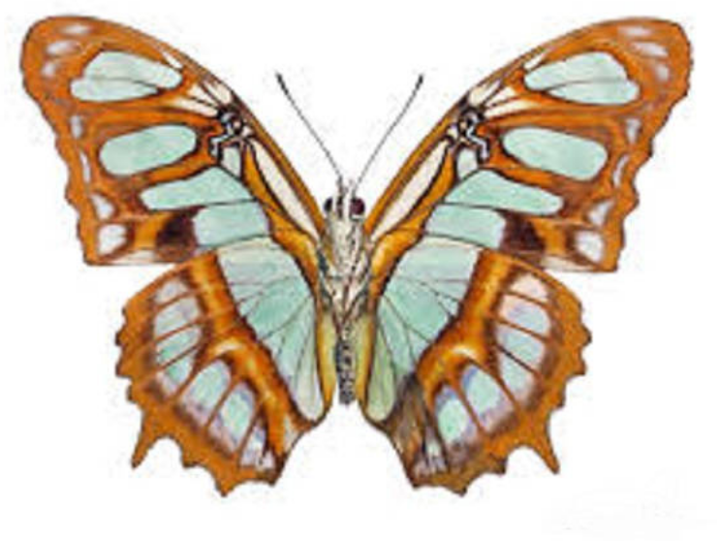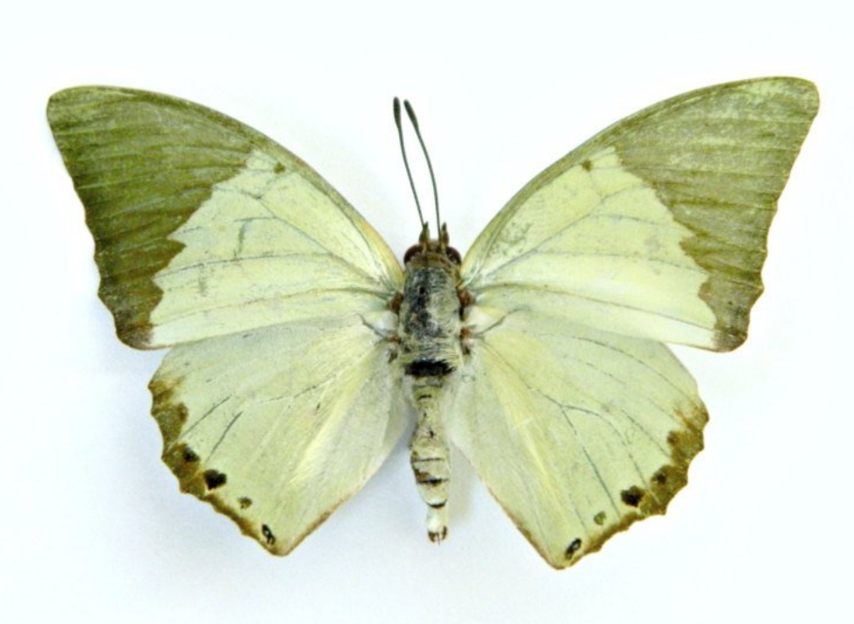

Autumn Days at the Butterfly Orchard

- Common Map Butterfly, Madagascar
- Red-Orange Albatross, Appias nero, Indonesia
- Red-Pink Scarlet Mormon, Papilio rumanzovia, Philippines
- Parides vertumnus astorius, South America
- Red Glider, Cymothoe sangris, Central Africa
- Striped Blue Crow Butterfly, Euploea mulicber, India
- Malay Lacewing, Cethosia hypsea palawana, Phillipines
- European Peacock Butterfly, Inachis io, Europe
- The Red Ringed Skirt, Hestina assimilis, Indonesi
- The Postman, Heliconius melpomeme amaryllis, Peru
- Malayan Eggfly, Hypolimnas anomala truentu,India

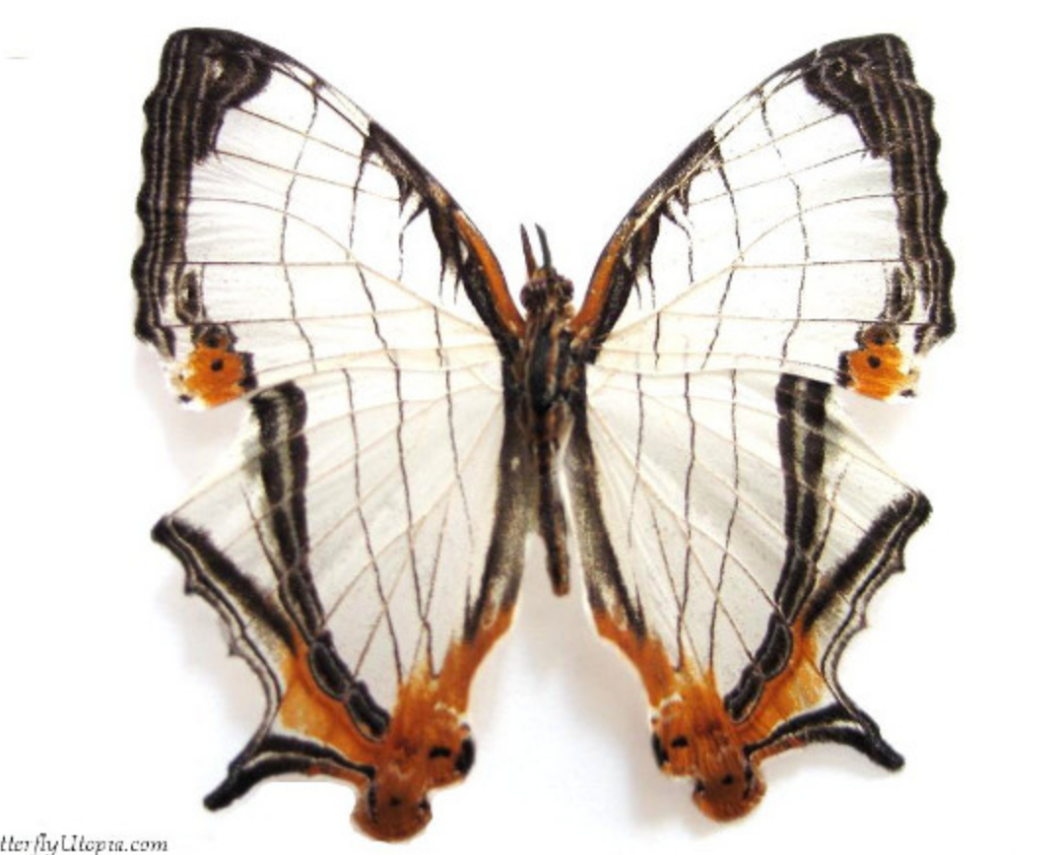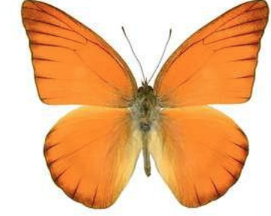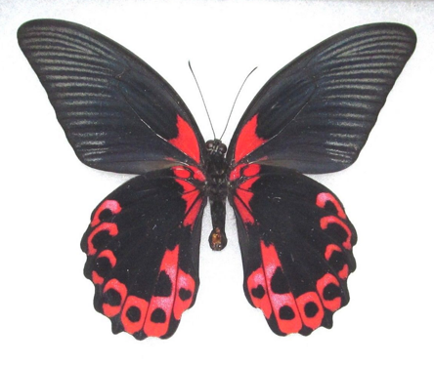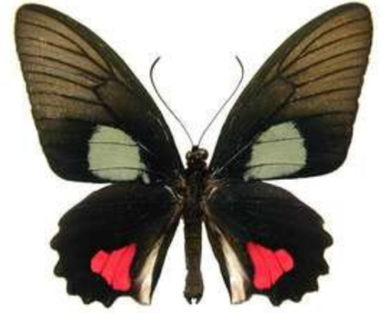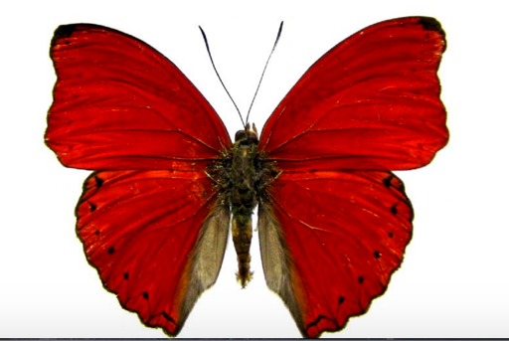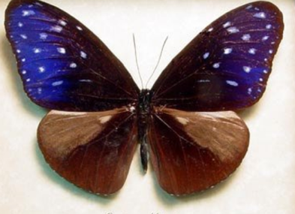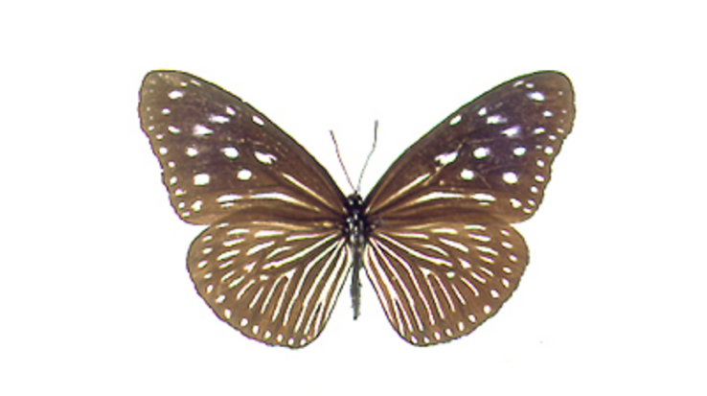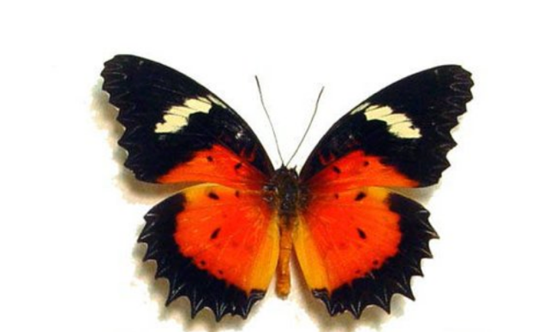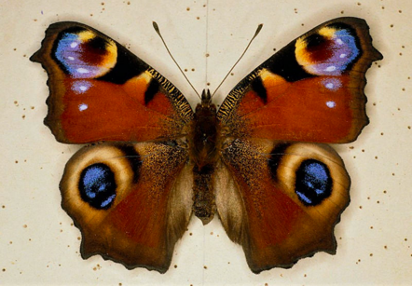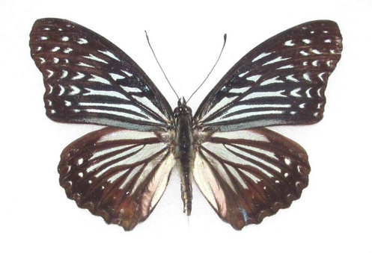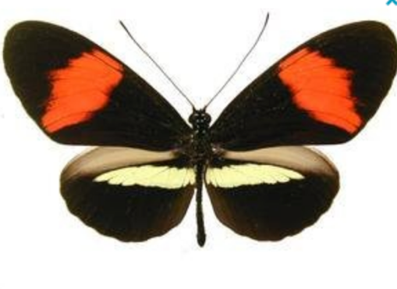

Wings at Dusk

- Blue Morpho, Morpho helenor peleides, Costa Rica
- Blue Buckeye, Precis rhadama, Africa

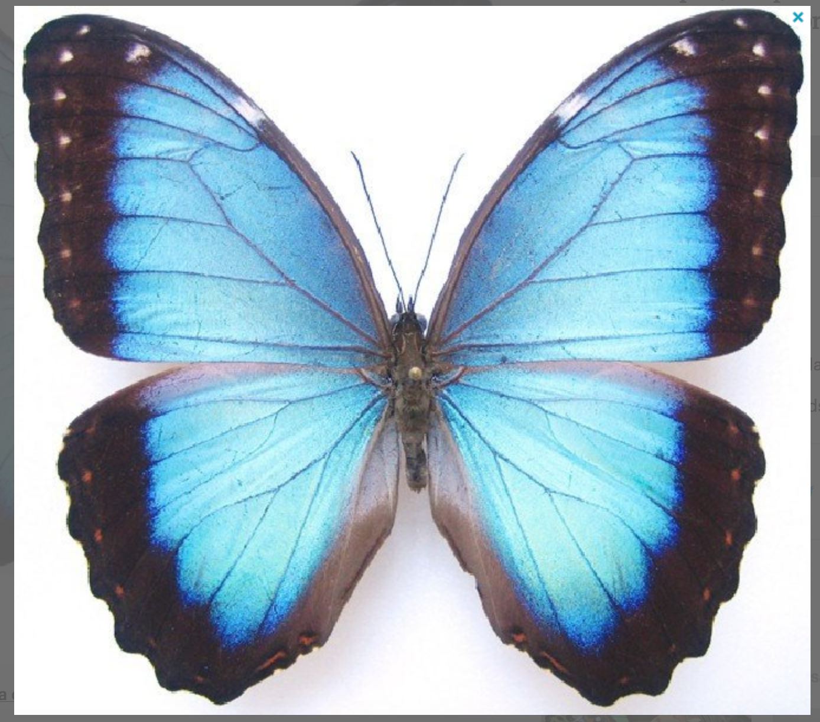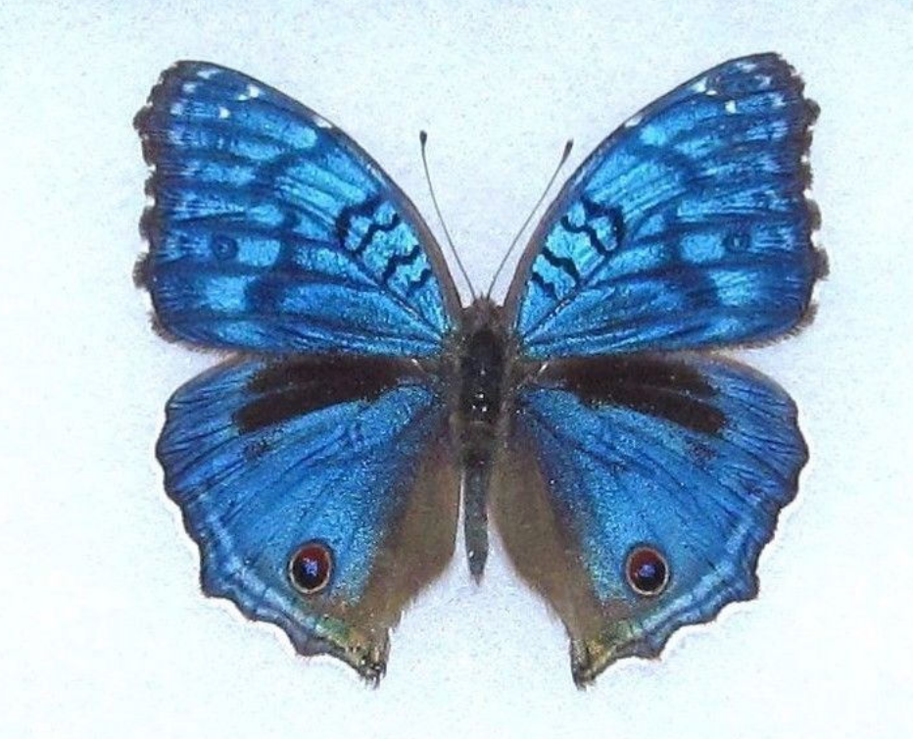

Sprinkled by Pixie Dust

1) The Painted Beauty, Pink-Blue Batesia hypochlora, Peru
2) The Painted Beauty, Yellow-Pink Verso Batesia hypochlora, Peru

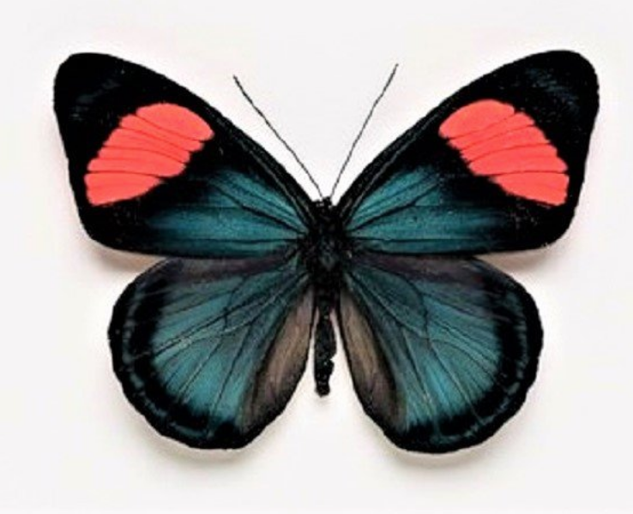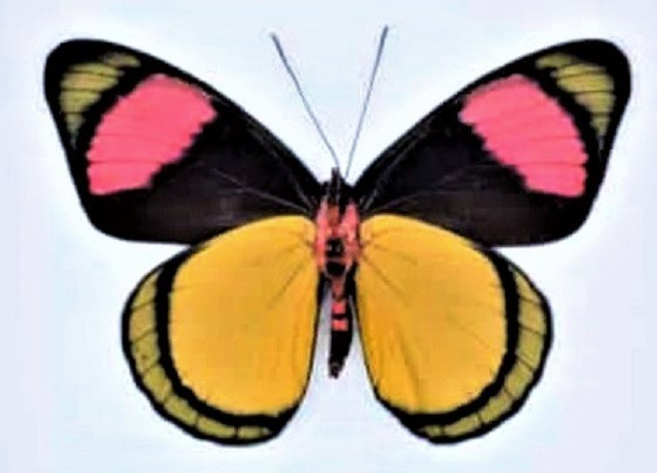

Butterfly Sunrise

1) Orange-barred Sulphur, Phoebis philea, Peru

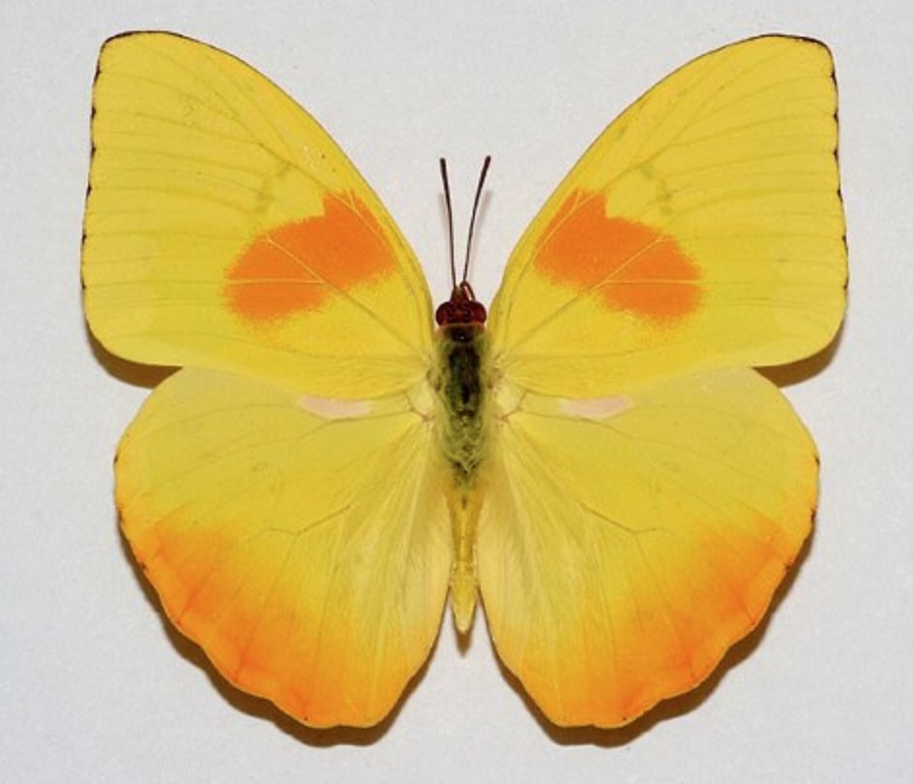

Iridescent Flight

- Black & White Rice Paper, Idea leuconoe, Indonesia

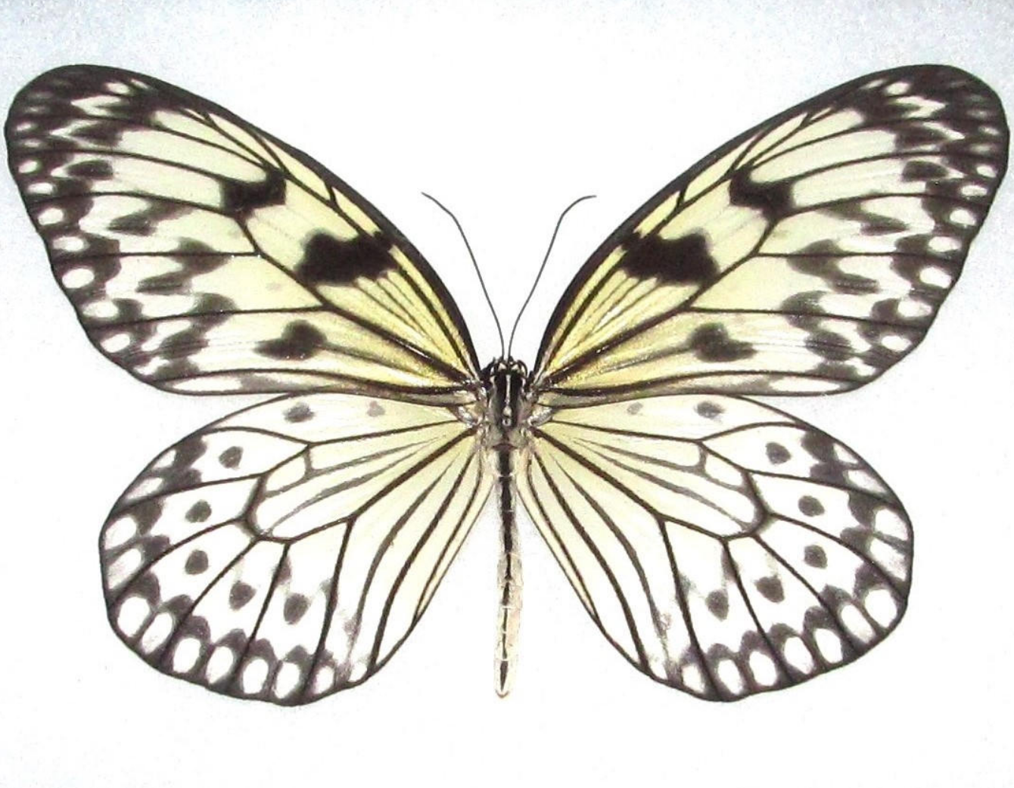

Butterfly Social

- Delias caeneus, Indonesia
- Male Goliath Birdwing, Ornithoptera goliath, Indonesia

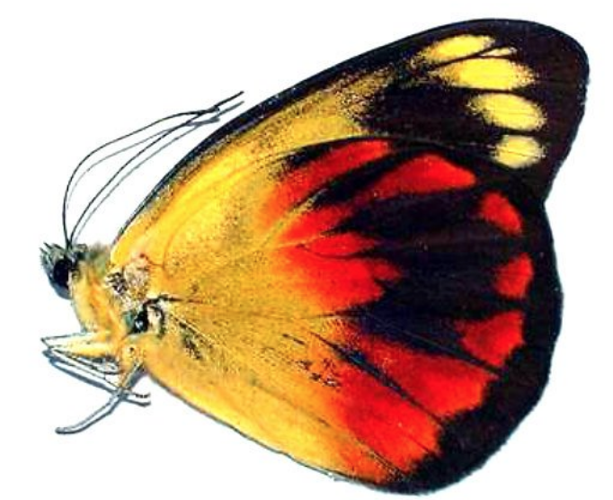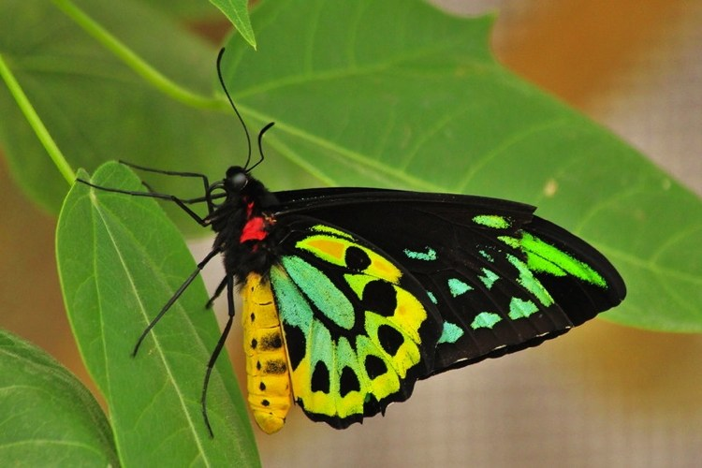

Electric Light Show

- Orange-Barred Sulphur, Phoebus philea, N. America

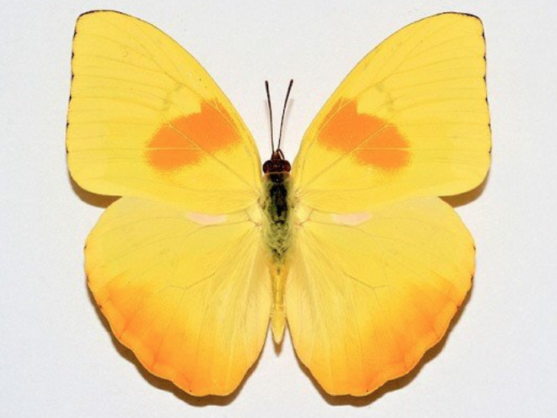

Seriously Badass Butterflies

- Emerald Birdwing Butterfly, Ornithoptera priamus, Indonesia
- Rajah Brooke’s Birdwing, Trogonotera brookiana, Malaysia
- Jewel Beetles, Thailand

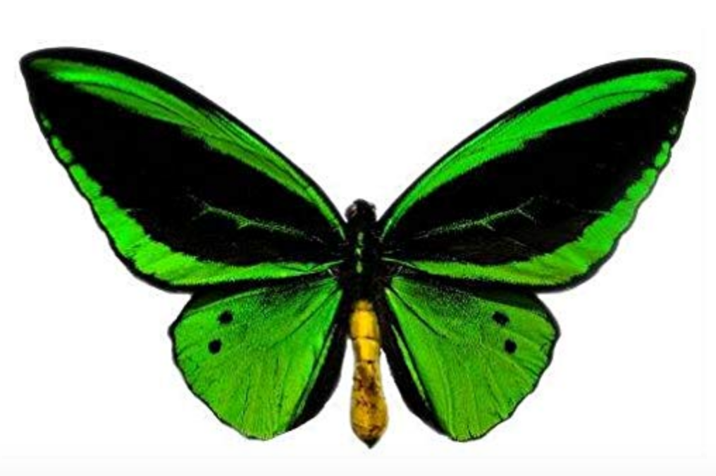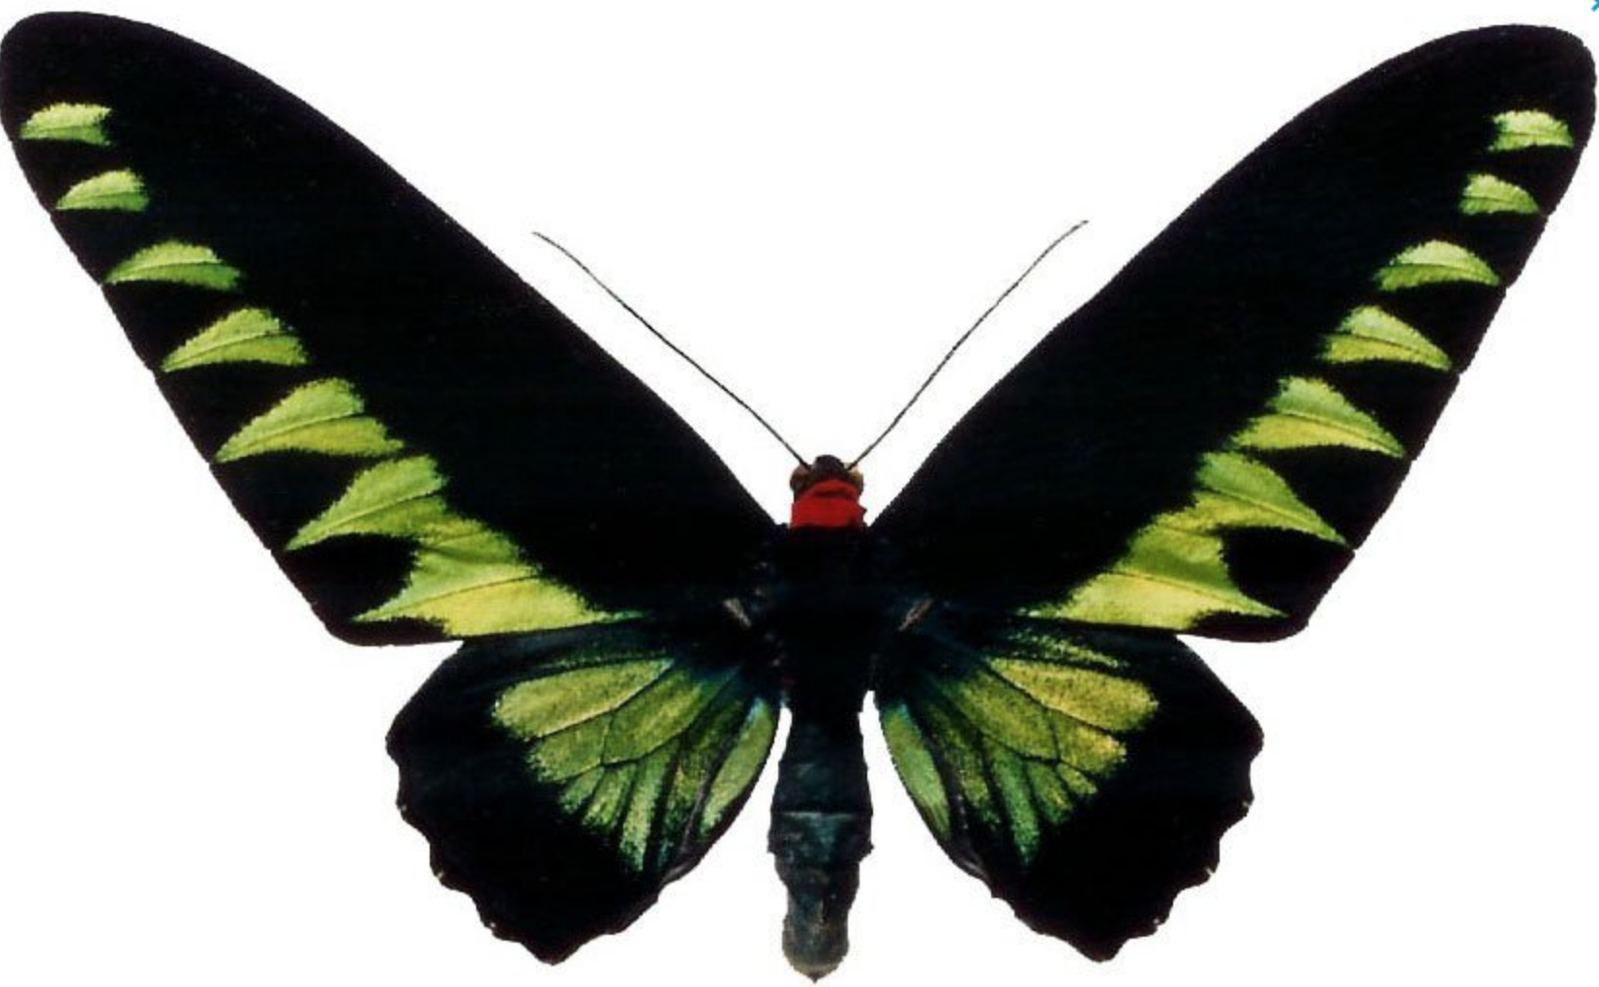
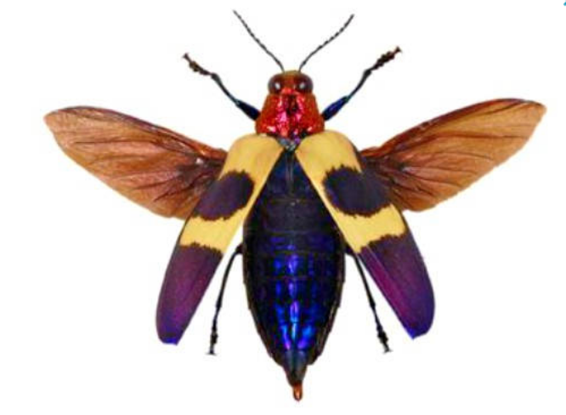

Galaxy

- Red-Orange Albatross, Appias nero, Indonesia
- Day flying Galaxy Moth, Zagaenidae amesia, Vietnam
- Leprieur’s Glory, Asterope leprieuri, Peru

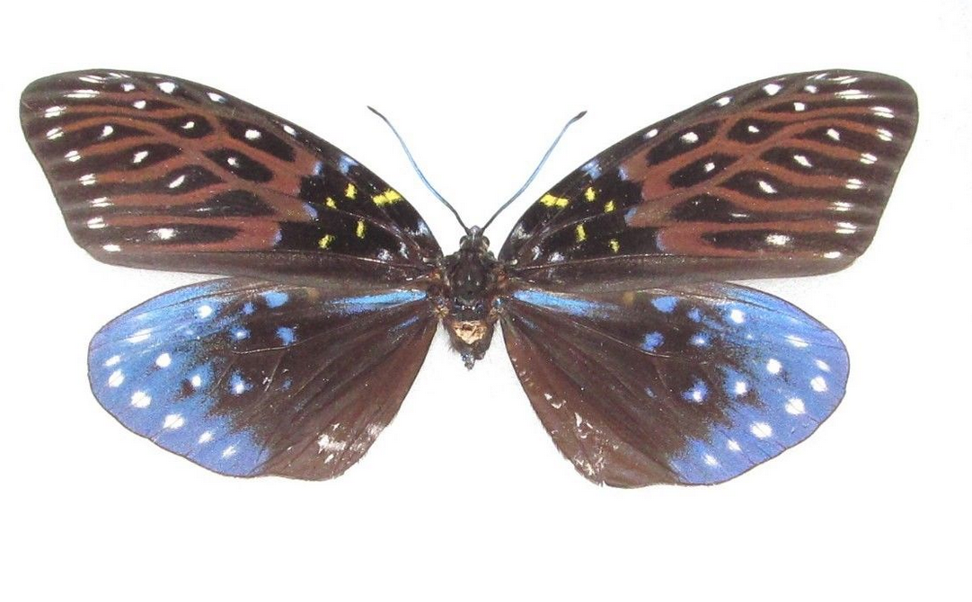

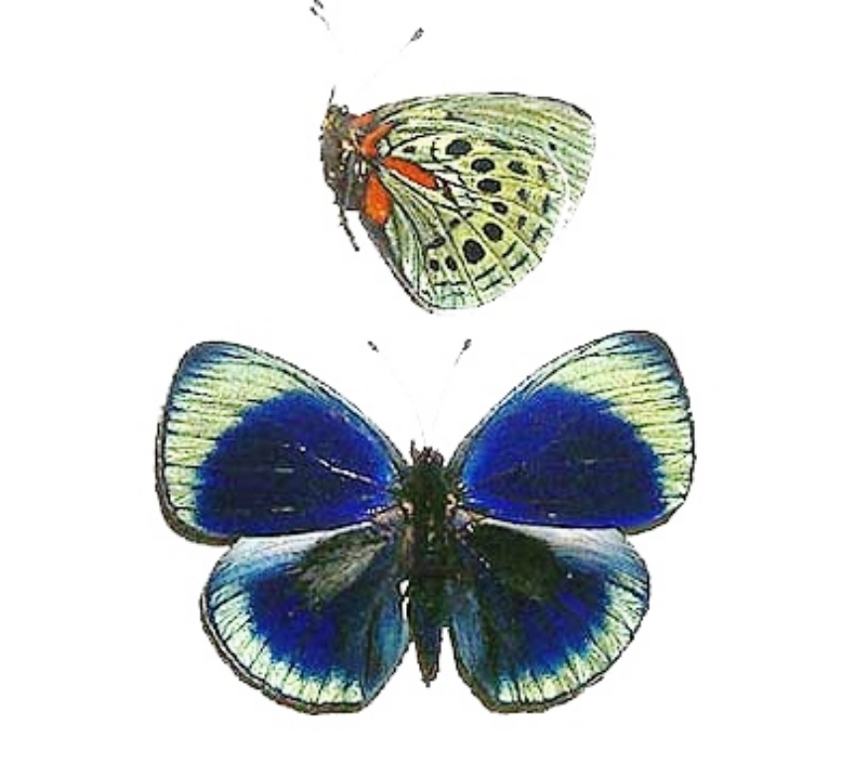
Broken Wings/Promises Kept # 3
(Leaf Mimic)

1) Indian Leaf Mimic, Kallima inachus, Indonesia

*Featuring various eclectic wings from various continents

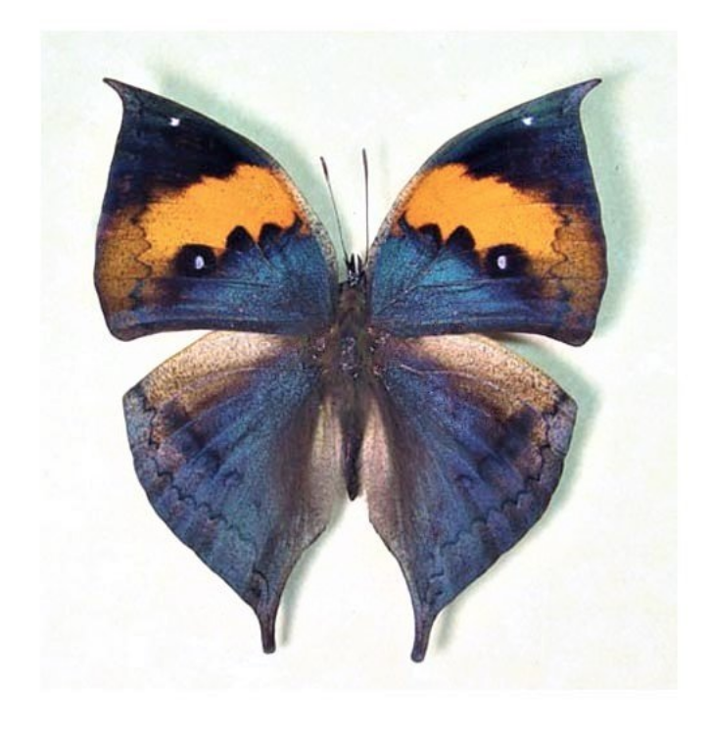

Field of Dreams

- The Painted Beauty, Pink-Blue Batesia hypochlora, Peru
- Purple Spotted Swallowtail - Graphium weiskei, Papau New Guinea
- Purple Sallya, Crenis pechueli, Africa
- Blue Pansy, Junonia Oenone, Africa
- African Purple Spot, Precis clelia, Africa
- Blue Precis rhadama, Africa
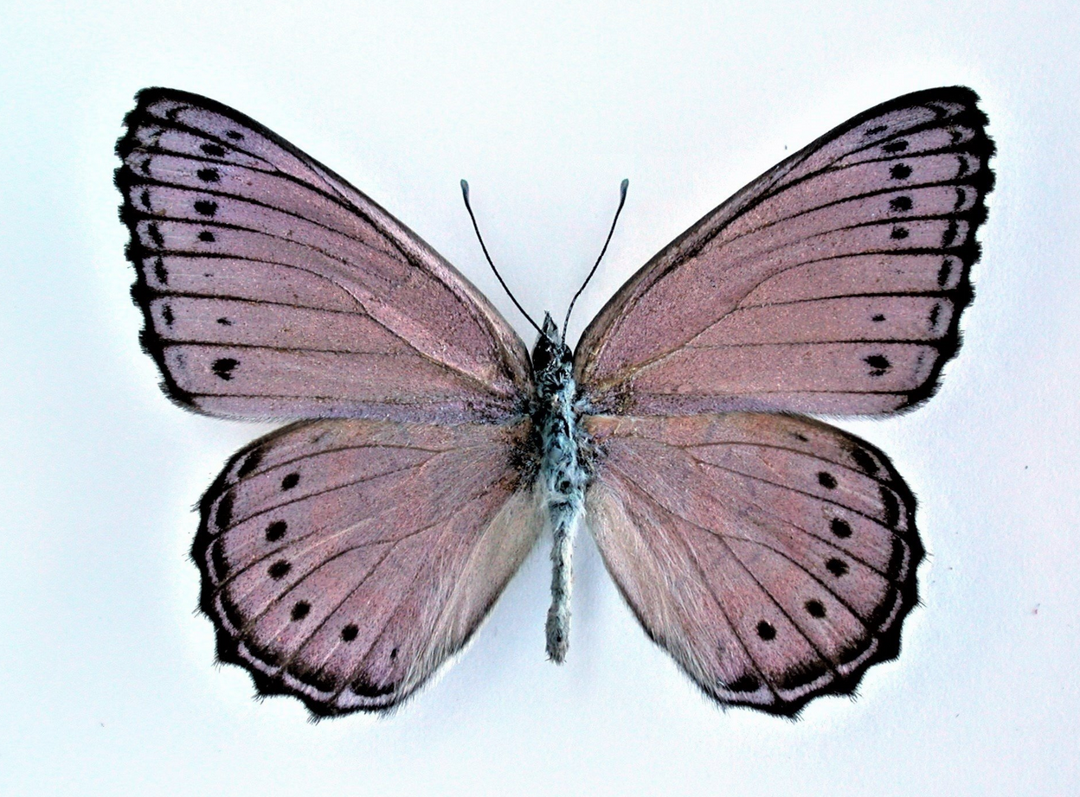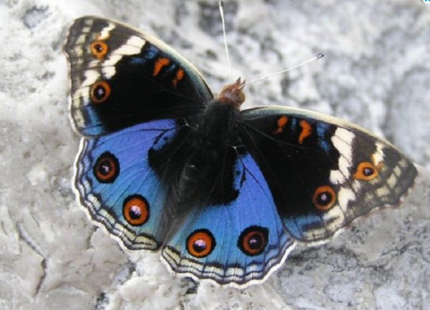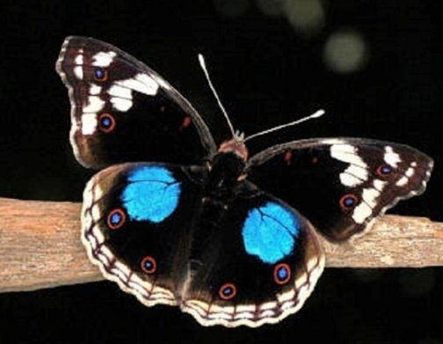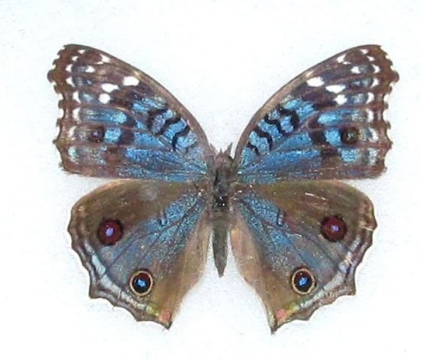

Snake Moths and Friends

- Snake Mimic/Atlas Saturn Moth, Attacus atlas, Indonesia
- Saturn Moth, Automeris tridens, Costa Rica
- Saturn Moth, Pink Yellow African Aurivillius, Africa
- Blue-Orange Asterope, Markii davisi, Peru
- Saturn Moth, Gonimbrasia rectilineata, Tanzania
- The Clipper, Parthonos sylvia, Philippines
- Saturn Moth, Springicampa, Montana
- Saturn Moth, Pink Orange Rothschildia, South America
- Orange Banded Daggertail, Marpesia corinna, Peru
10)Saturn Moth, Pink Dirphia Saturniidae, South America

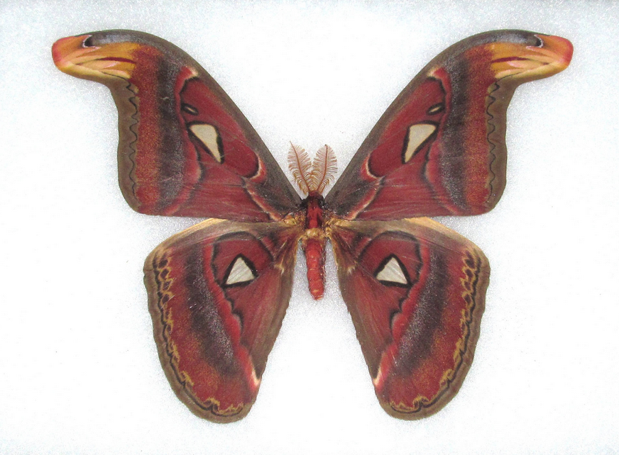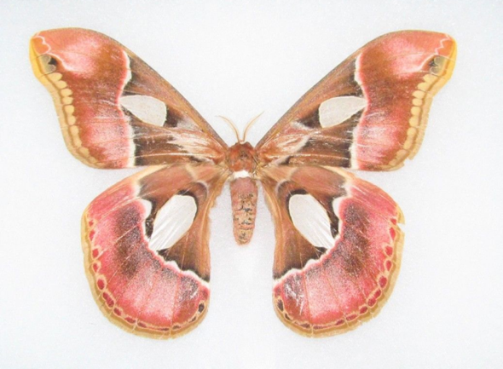
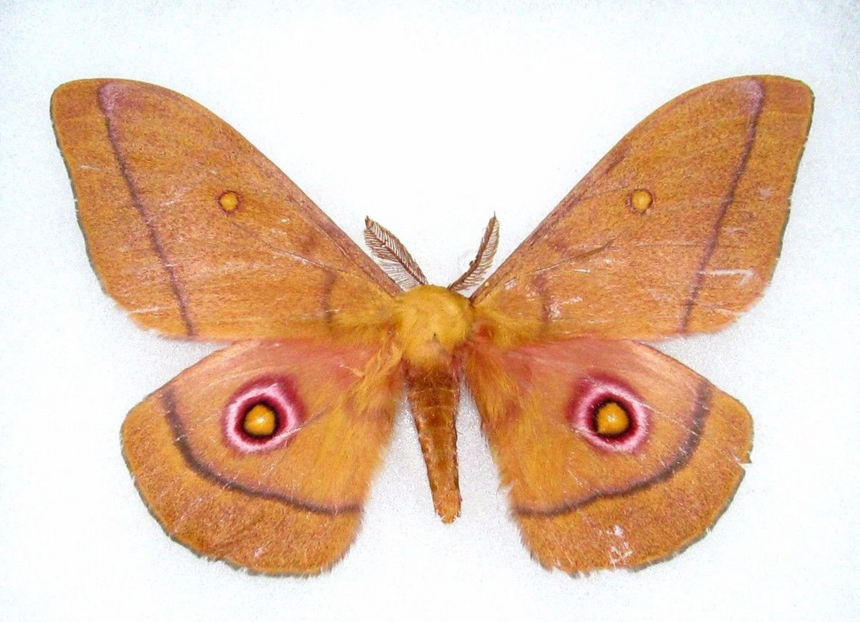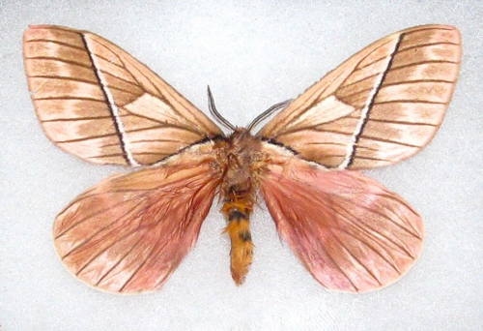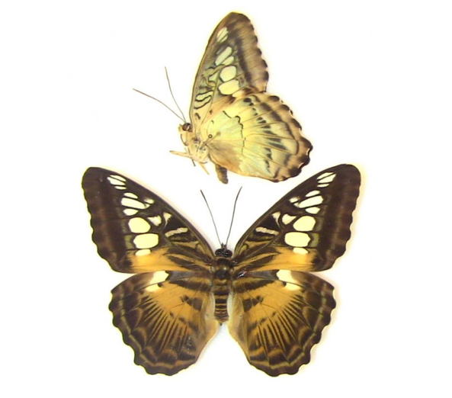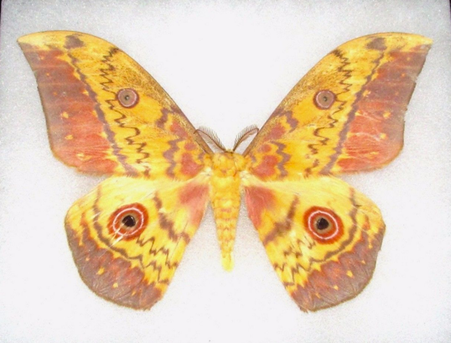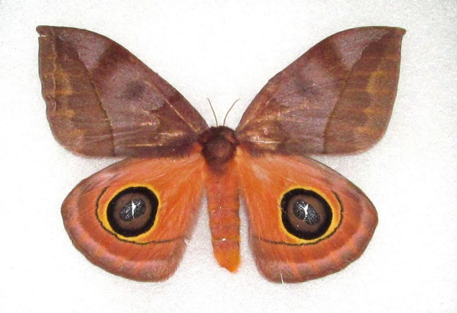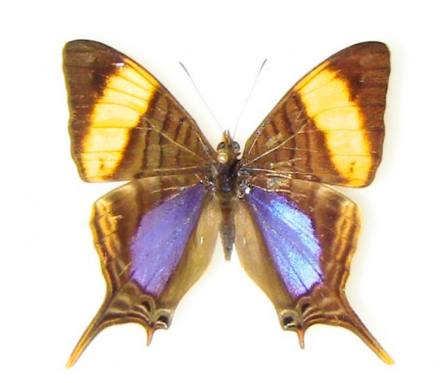
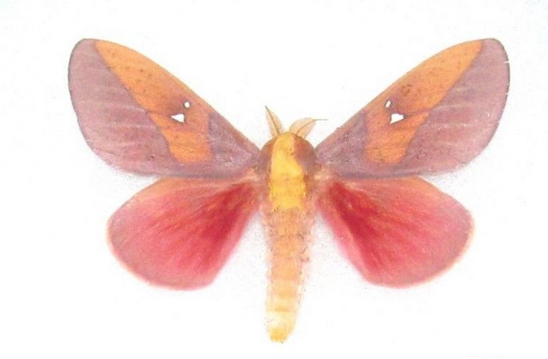

Grandmother’s Pearls

- Mother of Pearl, Salamas parchassus, Africa

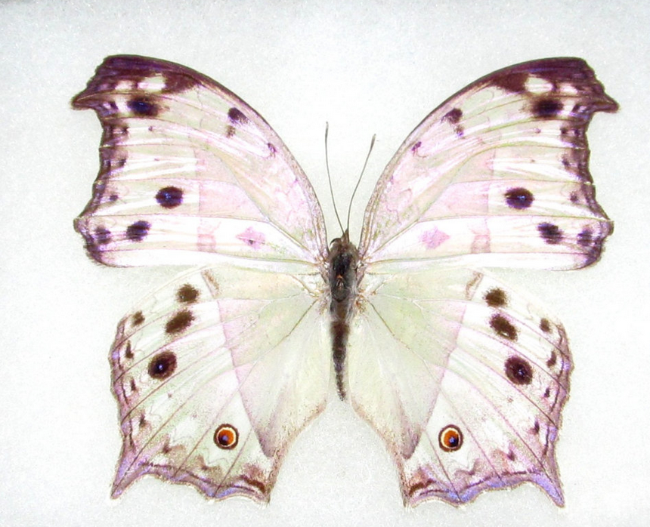

Earthscape

- Black & White Rice Paper Butterfly, Idea leuconoe,Indonesia
- Blue-Purple-Red Buckeye, Inachis io,. Europe
- Alpine Black Swallowtail, Papilio maacki (spring form), China
- Lilac Beauty, Salamis cacta, Africa

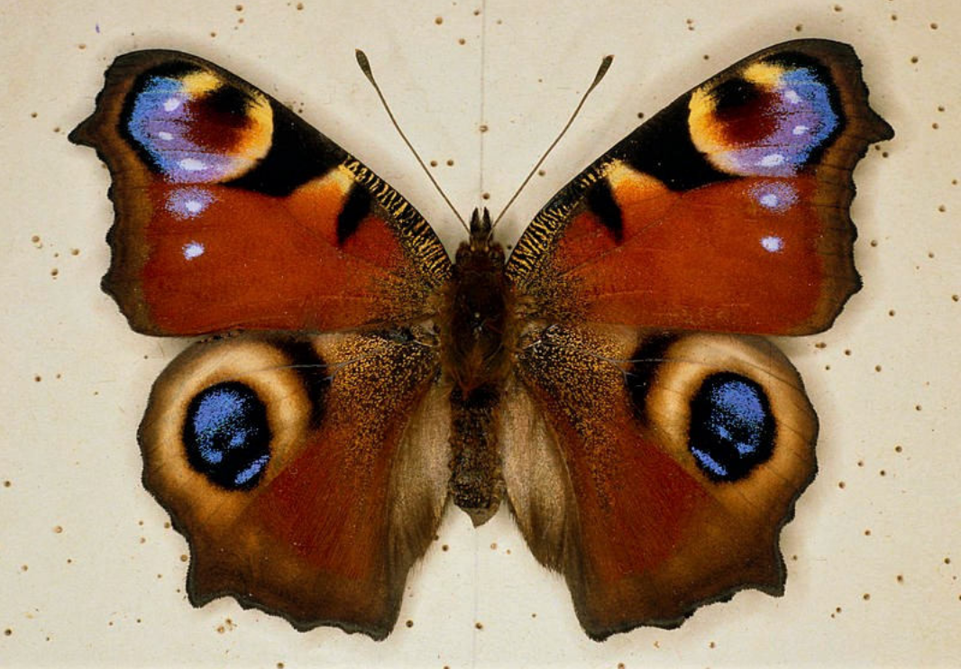
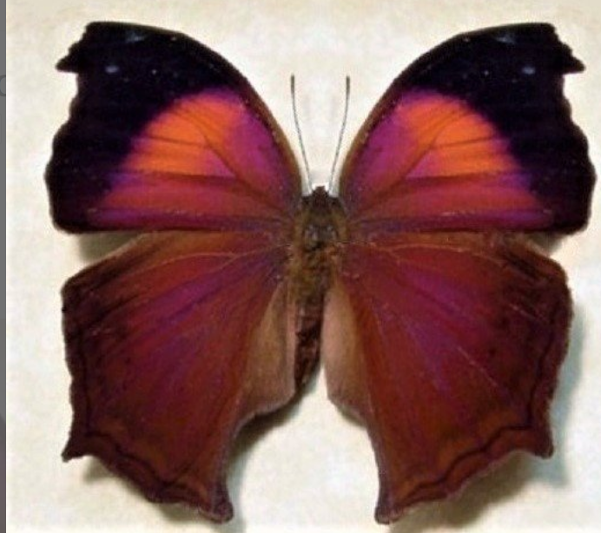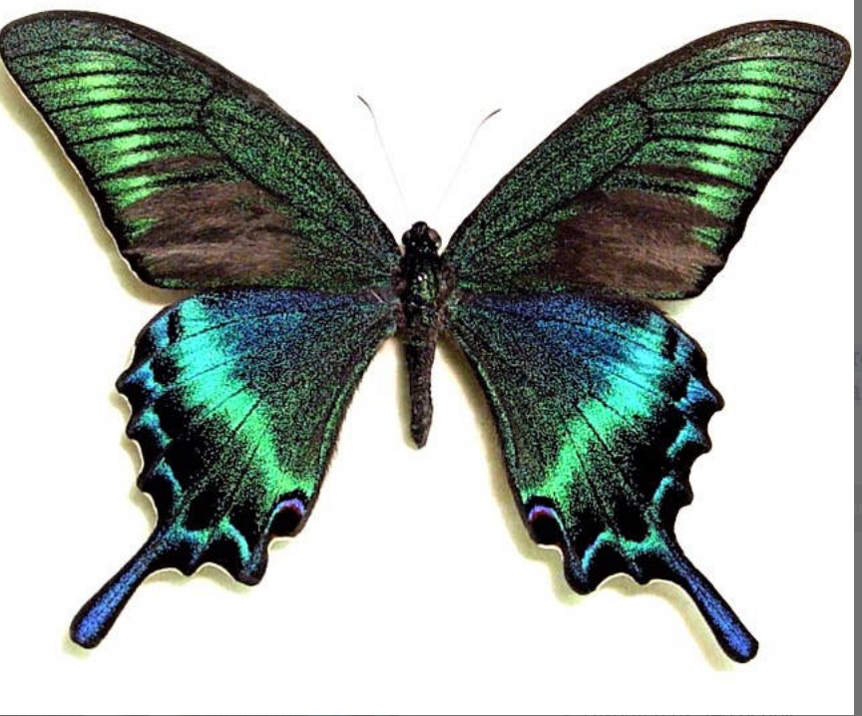

Victorian Butterfly Tea #2

- Black & White Rice Paper Butterfly, Idea leuconoe, Indonesia
- Glass Clear Wing Butterfly, Thyridia ithomiidae, S. America
- Scarlet Leafwing, Siderone nemesis, El Salvador

Pink Glass Wings

- Pink Glass Wing/Blushing Phantom Butterfly, Cithaerius merolin, S. America

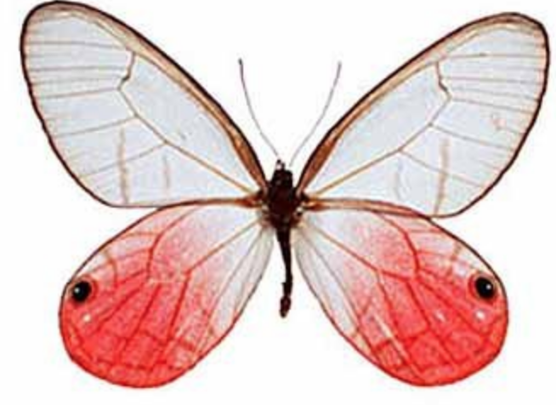

Monarch Migration

- Monarch Butterfly, Danaus plexippus, South America

Family Portrait

- Shining Purplewing, Eunica alpais, Peru
- Blue Buckeye - Junonia orithya, Japan
- Eight-eight butterfly, Callicore aegina , Peru
- The Dotted Glory, Blue Orange Asterope - Markii davisii, Peru

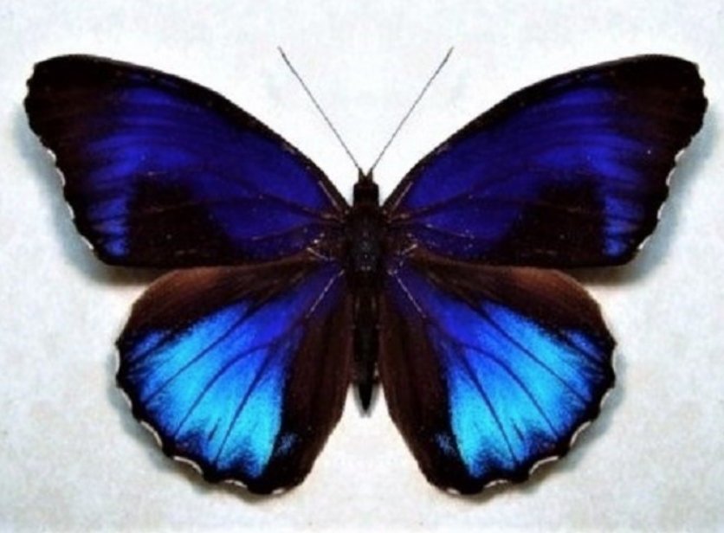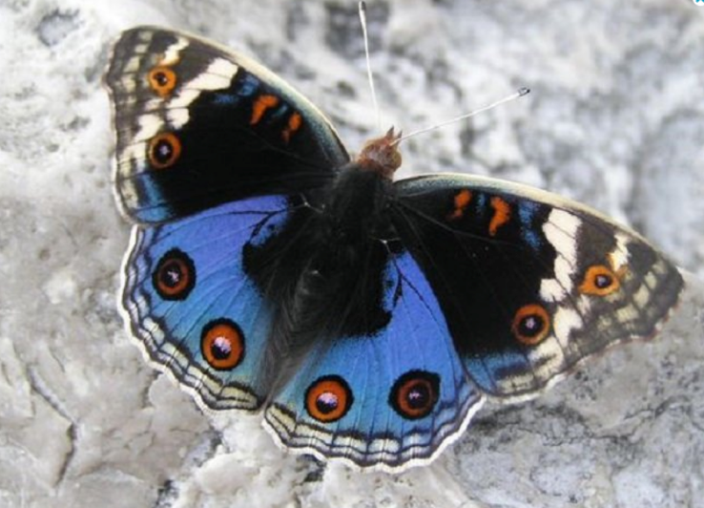
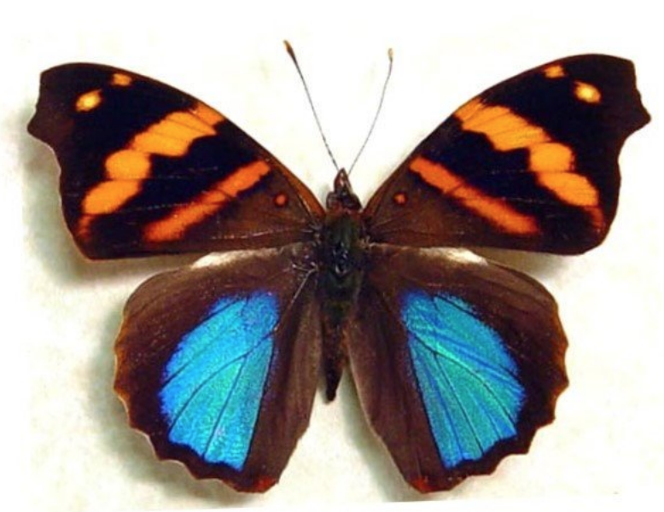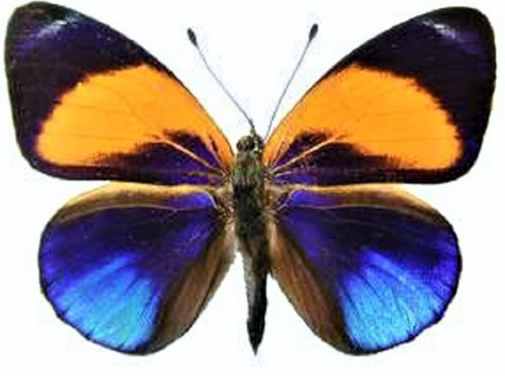

At The Water’s Edge

- Blue swordtail, Rhetus arcius, Peru
- Green Blue Hairstreak - Thecla lycaenidae
- Malachite Verso, Siproeta stelenes, Peru
- Orange Copper - Lycaena curetis, Indonesia
- Blue Green Forester Butterfly - Euphaedra eberti, Africa
- Blue Morpho, Peru (wings)
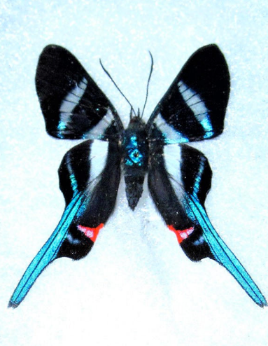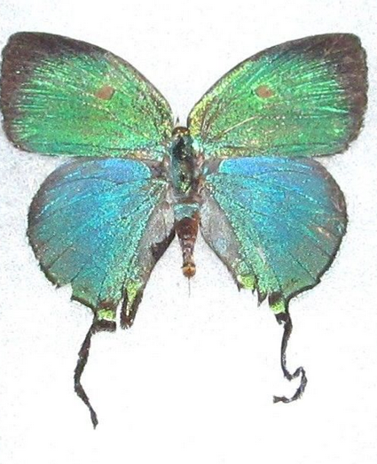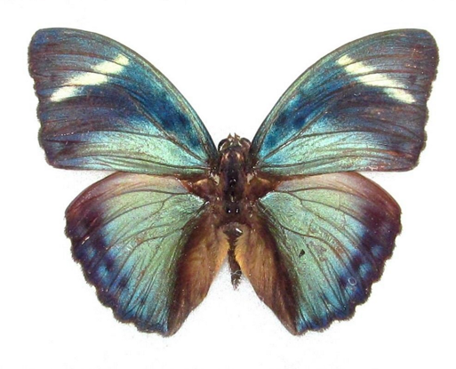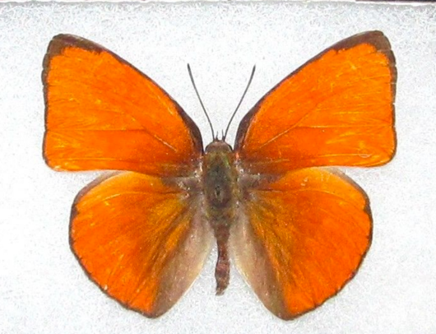
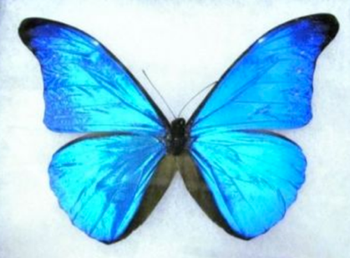

In the Wild

- Rajah Brooke’s Birdwing, Trogonotera brookiana, Malaysia
- Madagascan Giant Swallowtail Butterfly, Pailio antenor, Madagascar
- Golden Morpho, Morpho rhetenor cacica, Peru

Featuring an array of Jewel beetles, Scarab beetles and Dragonflies from a variety of continents.
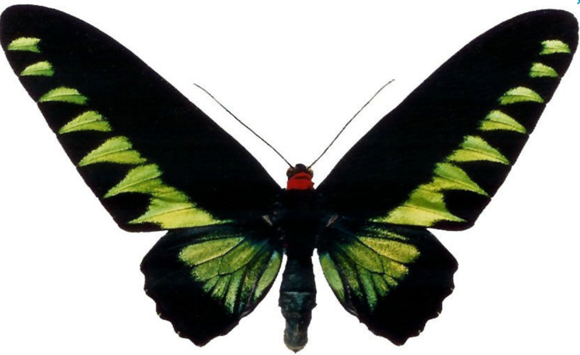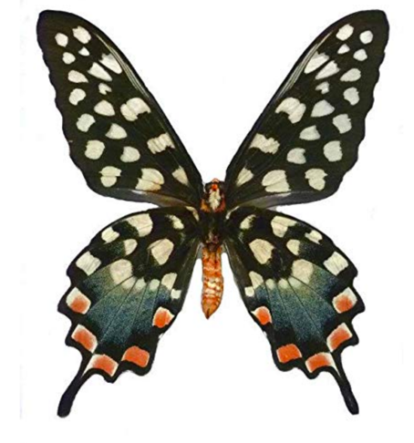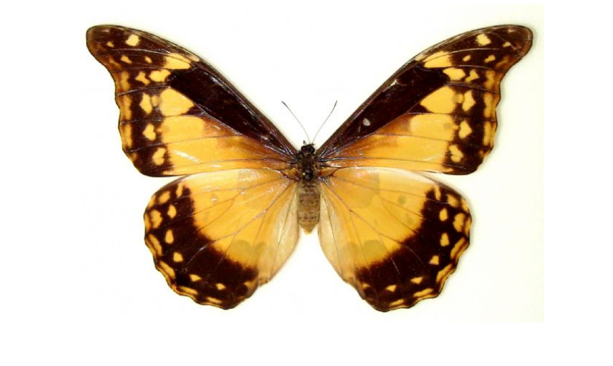

Eye of the Storm

1) Leprieur’s Glory, Asterope leprieuri, Peru
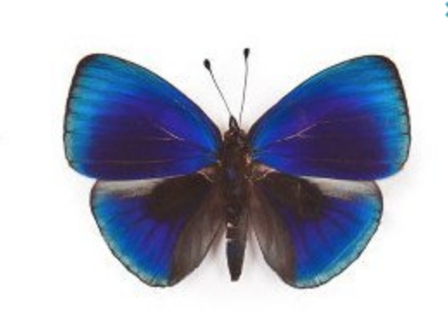

Rainbow Wheat

- Common Bluebotle, Graphium saepedon, Indonesia
- Cicada, Tosena paviei, Thailand
- The Postman, Heliconius melpomeme
- White Morpho, Morpho epistrophus catenaria, Brazil
- Sky Blue Morpho, Morpho peleides, Guyana
- Cicada, Tosena splendida, Thailand
- Cicada, Ambrogaeanna ambra, Thailand
- Blue Buckeye, Rhadama precis, Africa
- Pink-Purple Anaea tyrianthina, Peru
11) Blue Velvet, Salamis temora, Africa
- Cicada, Angamiana floridula, Thailand
- Great Mormon Swallowtail, Papilio memnon agenor, SE Asia
- Laurel Swallowtail, Papilio palamedes, North America
- Cocoa Mort Bleu Butterfly, Caligo teucer semicaerulea, Costa Rica
- Common Faun, Faunis canens, India
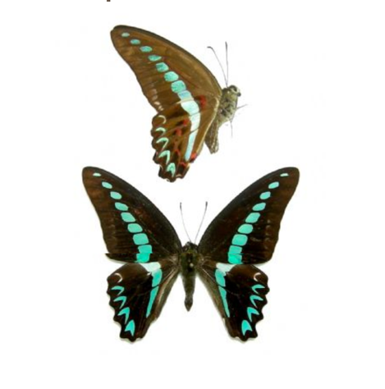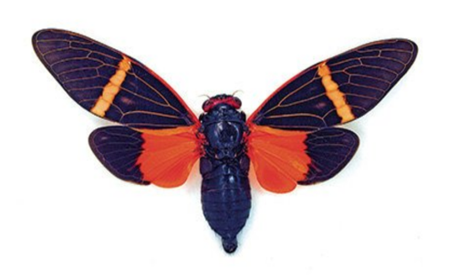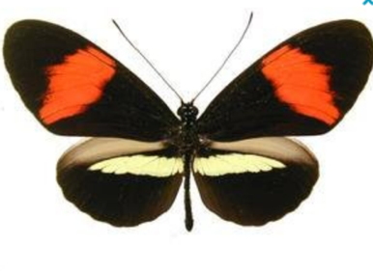
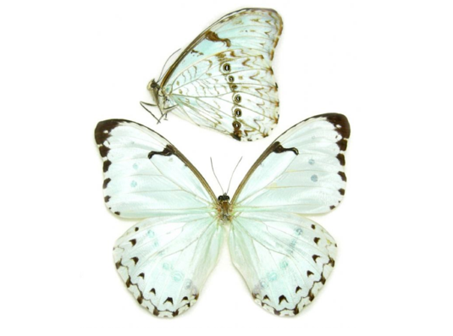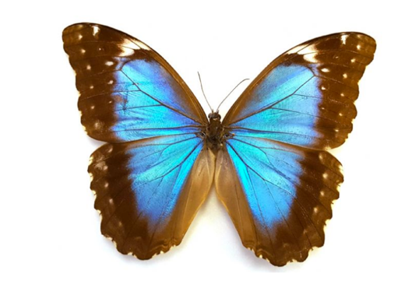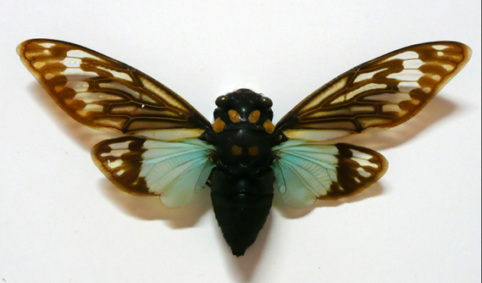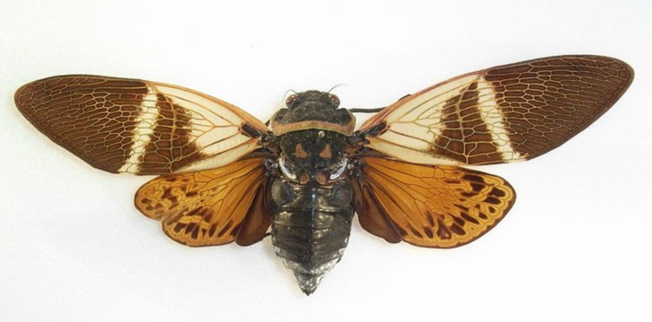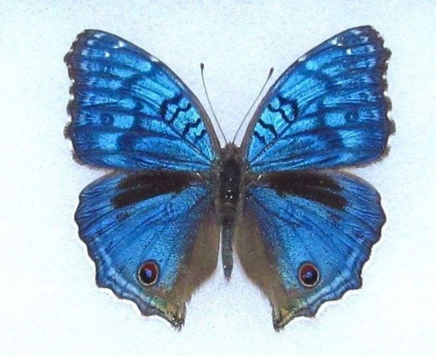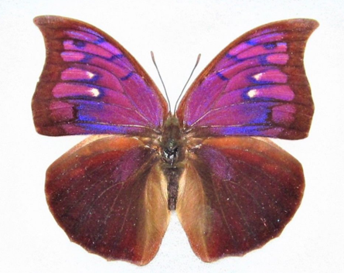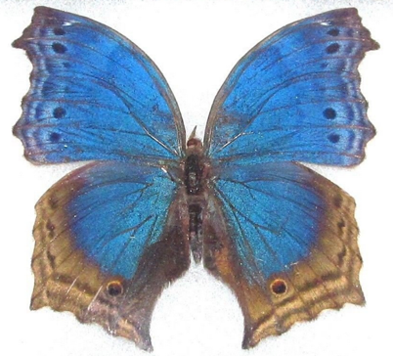

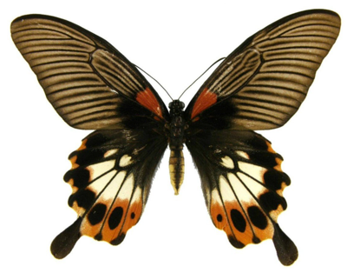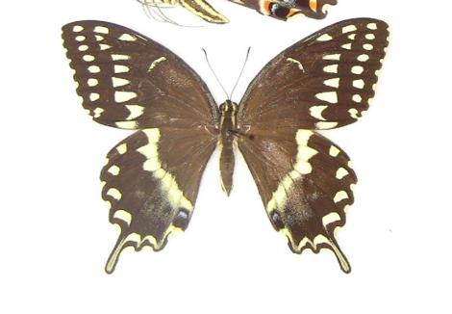
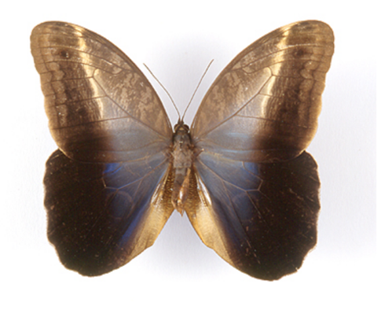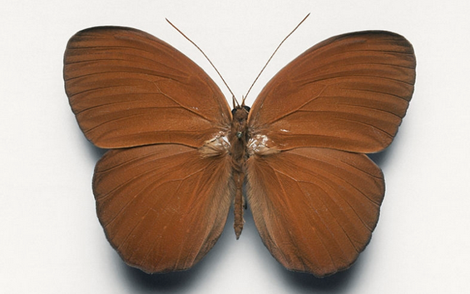

Streams and Dreams

- Red Orange Pseudoacraea clarkii, Africa
- Day Flying Moth, Erasmia pulcheria chinensis, Thailand
- The Juno Silverspot, Orange Silver Dione juno verso, Peru

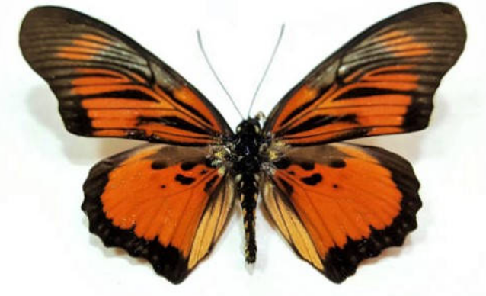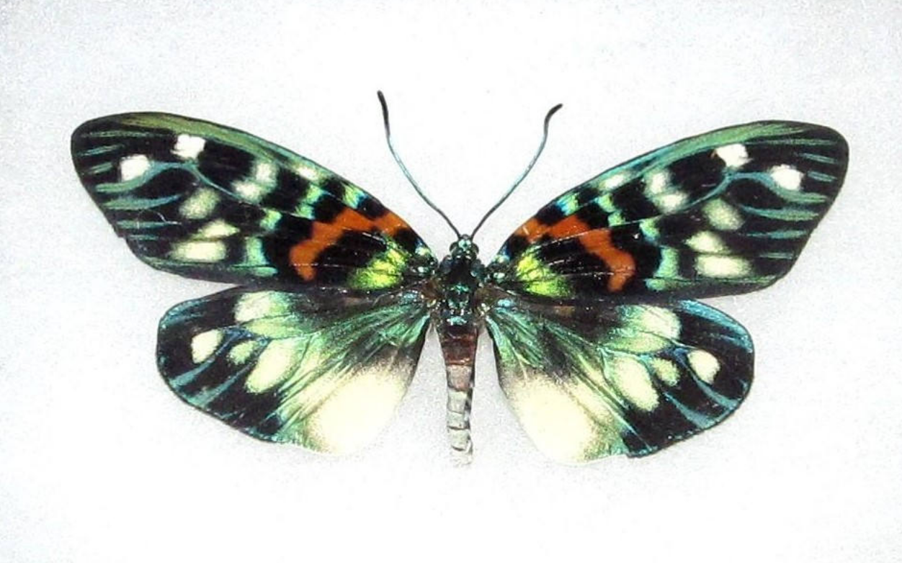

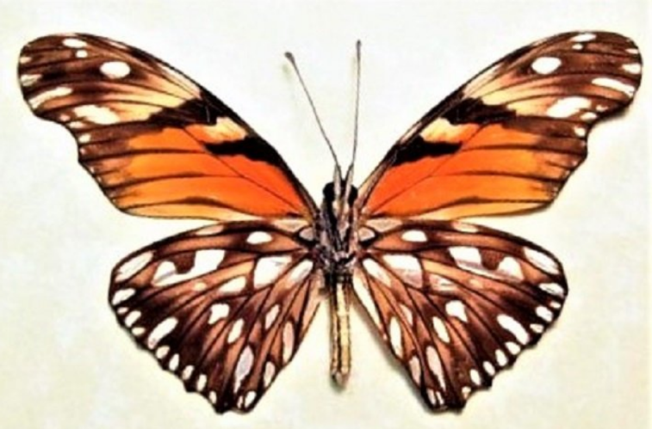

Awkward Teenage Dance Party

- Common Green Charaxes, Charaxes eupale, Africa
- Black & White Rice Paper, Idea leuconoe, Philippines
- Red Lacewing, Cethosia bilbis, Indonesia
- Giant Madagascan Swallowtail, Pharnacophagus antenor, Madagascar
- Great Blue Zalmoxis, Papilio zalmoxis, Africa
- Malachite Butterfly, Victorina siproeta stelenes, Peru
- Red Spotted Purple Admiral, Limenitis arthemis astyanax, New York
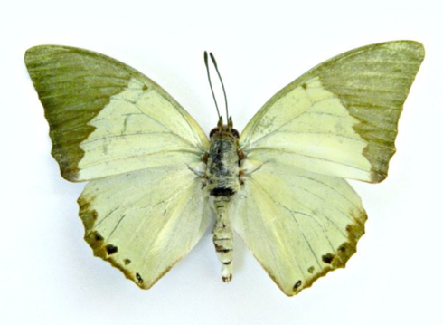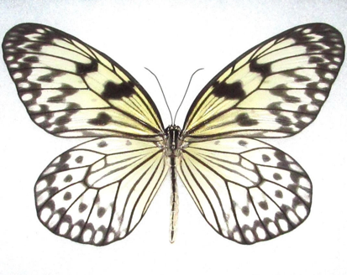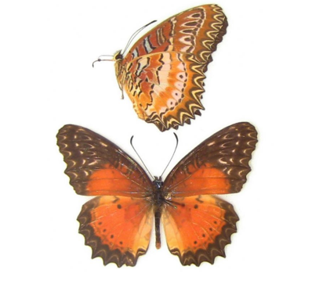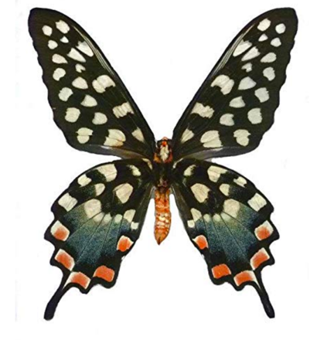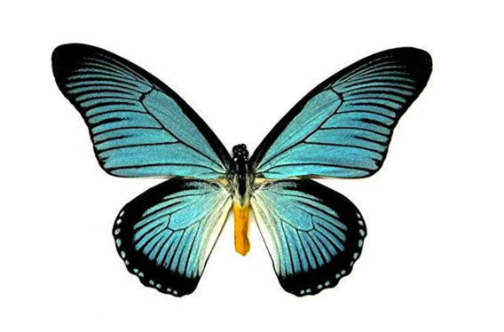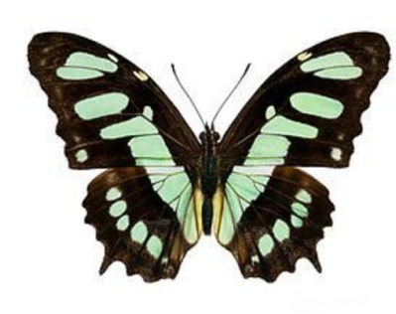
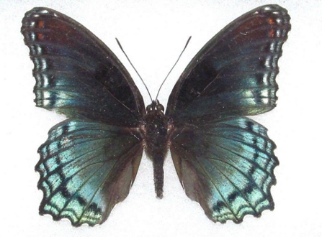

Big Blue

- Sky Blue Morpho, Morpho menelaus, Guyana
- Blue Morpho, Rhetenor cacica, Peru
- Blue Buckeye Butterfly, Junovia orithya, Japan
- Red-Orange Albatross, Appias nero, Indonesia
- Eugenia Moth, Chetone historio, Peru
- Red Pink Anaea ryphea, Peru
- Blue Banded Morpho, Morpho deidamia annae, Guyana

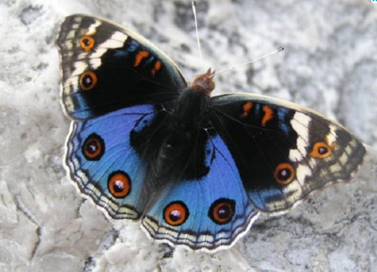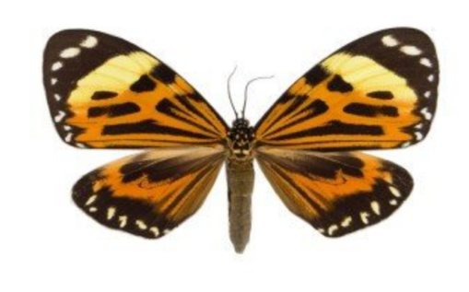

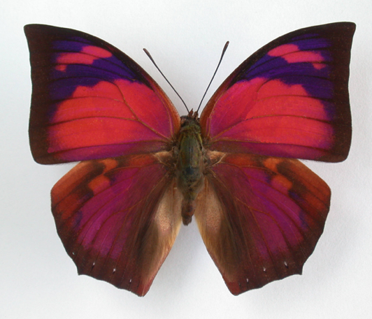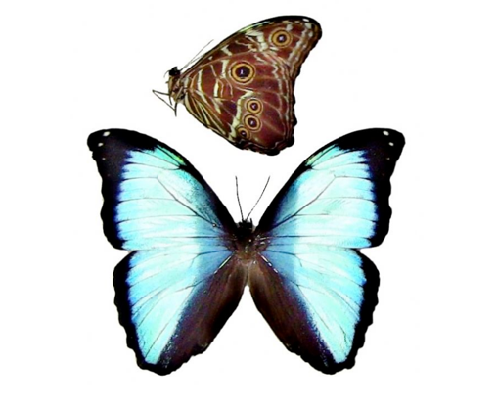

Kaleidoscope

- Leprieur’s Glory, Asterope leprieuri, Peru

Featuring eclectic wings gathered from various continents

Bejeweled Pool

- Pipleine Swallowtail Verso, Blue Battus philenor, N. America
- The Blue Peacock, Papilio arcturus, Indonesia
- Apollo Metalmark, Lyroteryx apollonia, Peru
- Purple Spotted Swallowtail, Graphium weiskei, Papa New Guinea
- Day flying moth, Eterusia replete, Thailand
- Purple Sallya, Crensis pechuli, Africa
- Blue Buckeye, Precis rhadama, Africa
- Common Pink Forester, Euphaedra xypete, Africa
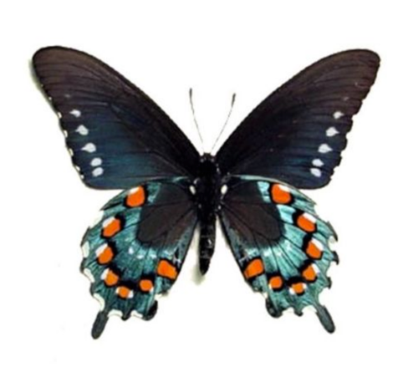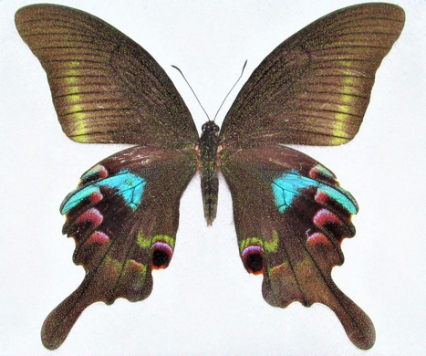
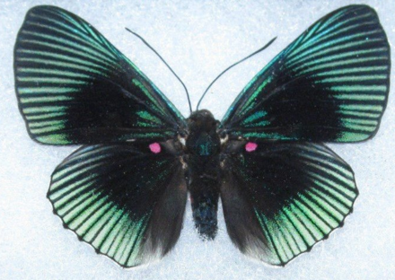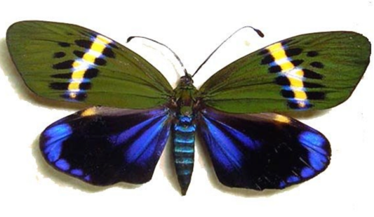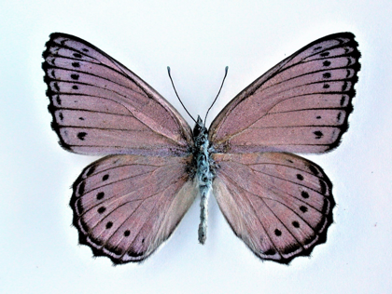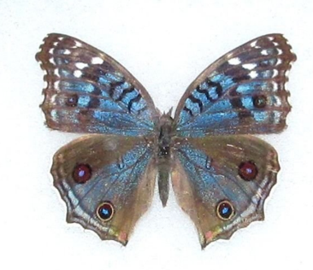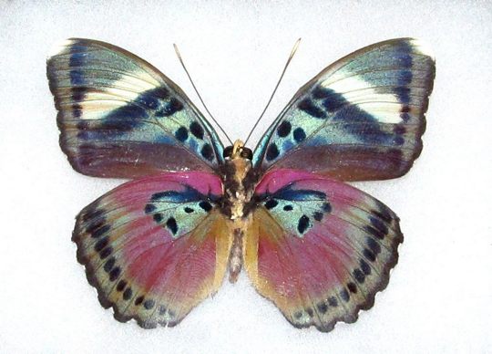

Butterfly Coachella

- Eastern Yellow Tiger Swallowtail, Papilio glaucus, N. America
- Purple Sallya, Crenis pecheuli, Africa
- Red Glider, Cymothoe sangaris, Africa
- Alpine Black Swallowtail, Papilio maacki (spring form), China
- Golden Glass Wing, Haetera piera negra, Peru
- Foucheri, Morpho telemachus, Peru

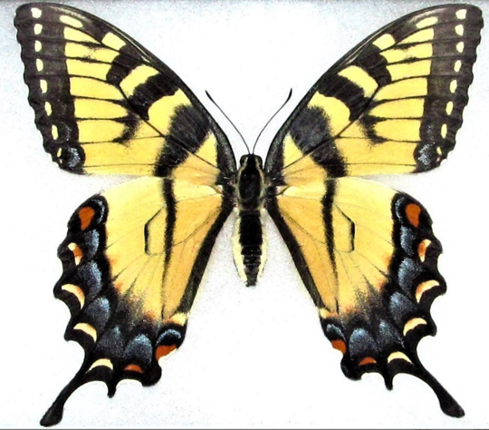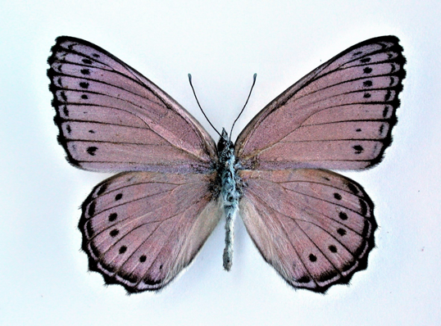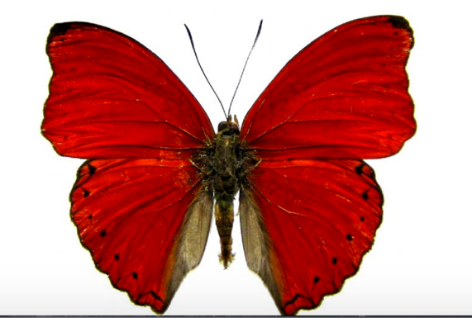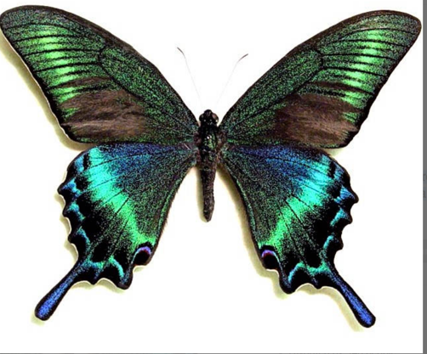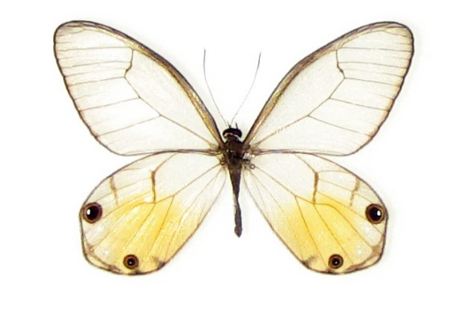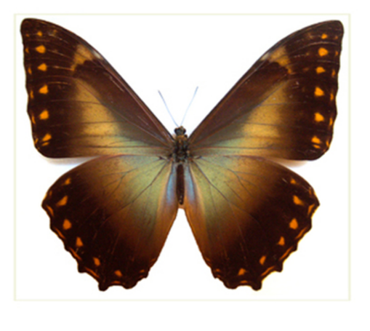

Butterfly Puddler

- Blue Arizona Sister Verso, Adelpha eulalia, N. America
- Malachite Verso, Siproeta stelenes, Peru
- Spanish Moon Moth, Luna graellsia isabellae, Spain
- Common Bluebottle, Graphium sarpedon, Indonesia (wings closed)

Featuring butterfly species with wings closed from several continetns.

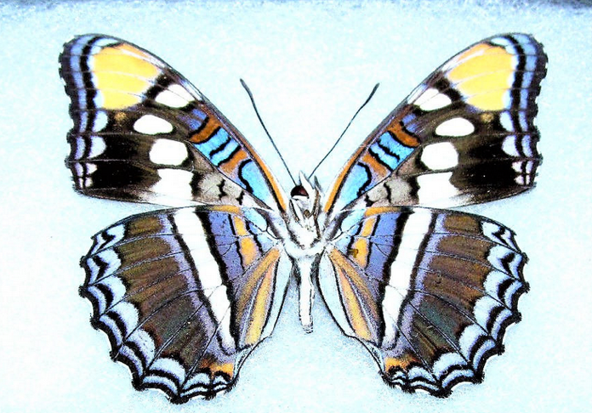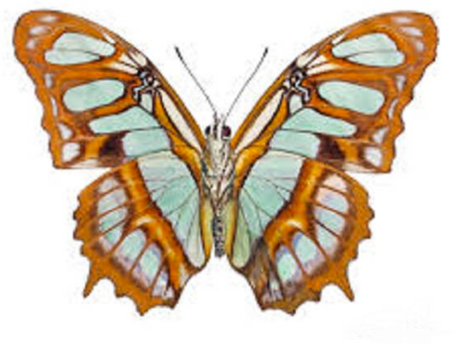
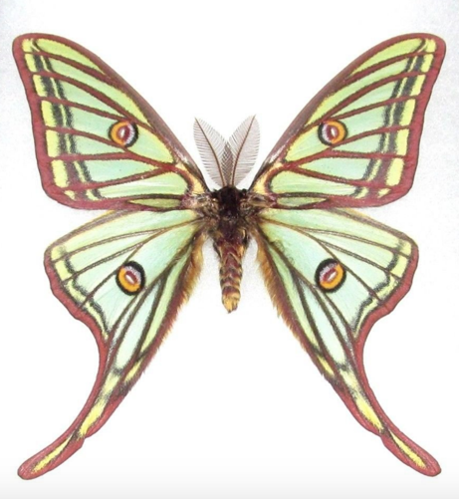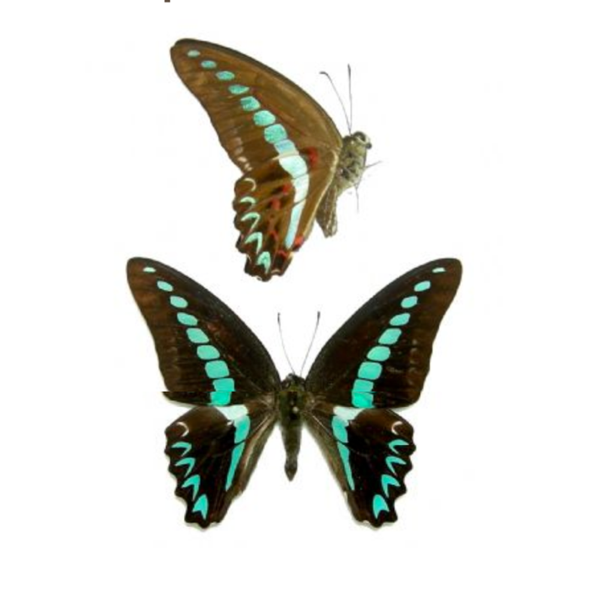

Broken Wings/Promises Kept #1
(Golden Glass Wing)

- Golden Glass Wing Butterfly, Haetera piera negra, Peru

Featuring eclectic wings gathered from various continents

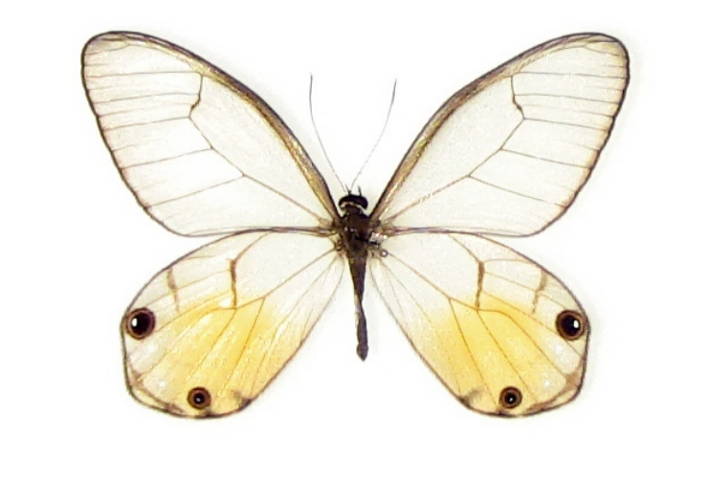

Morpho Moon

1) Sky Blue Morpho, Morpho menelaus menelaus, Guyana

Broken Wings/Promises Kept #2

- Scarlet Mormon, Red-Pink Papillio Rumanzovia, Philippines

Featuring eclectic wings gathered from various continents

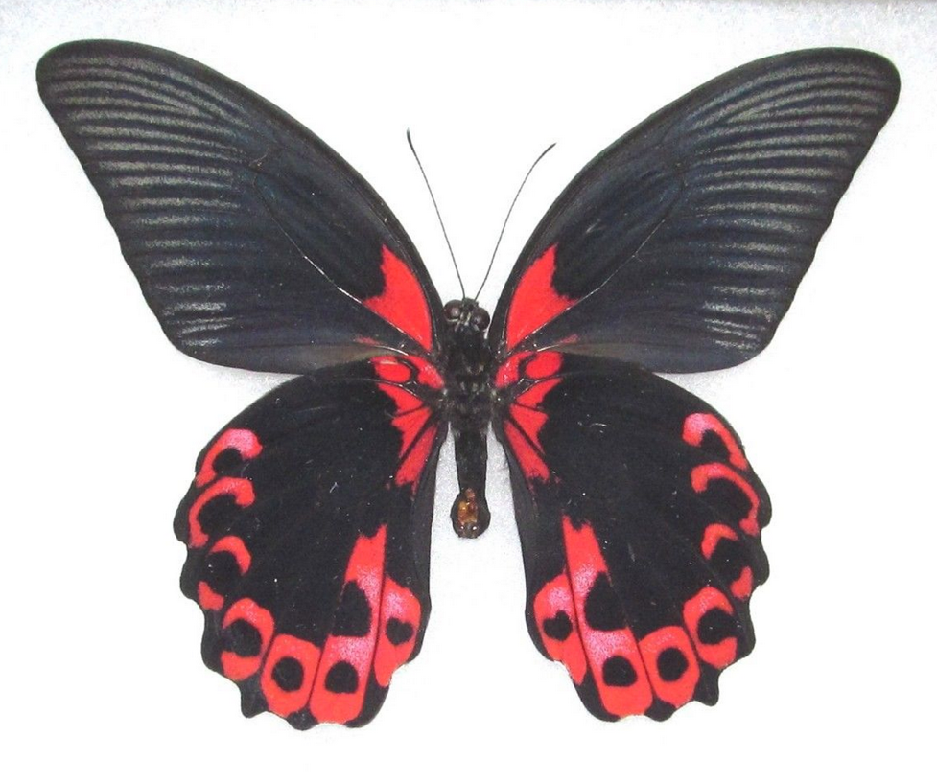

Butterfly Nebula

- Owl Butterfly, Caligo brasilensis sulensis, Columbia
- Leprieur’s Glory, Asterope leprieuri, Peru
- Alpine Black Swallowtail, Papilio maacki (spring form), China
- BD Butterfly, Callicore cynosura, Peru
- Red Pink Paulogramma peristera, Peru
- Blue Starry Night, Hamadryas laodamia, Peru
- Red Spotted Purple Admiral, Limenitis arthemis astyanax, New York

Featuring eclectic wings gathered from various continents including S. American Monarch Butterfly wings and Blue-Green Swallowtail wings from Africa.
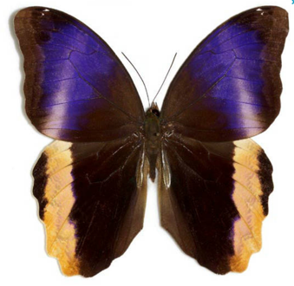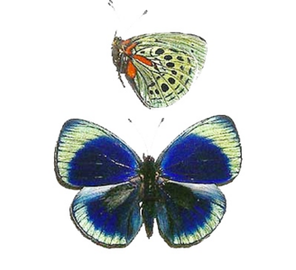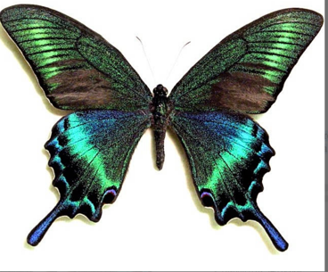
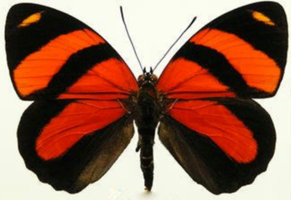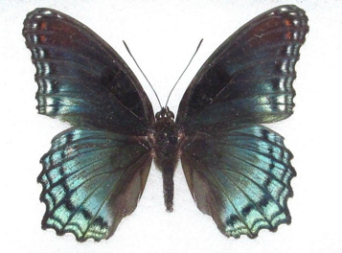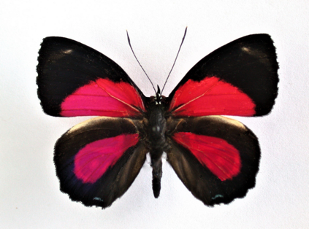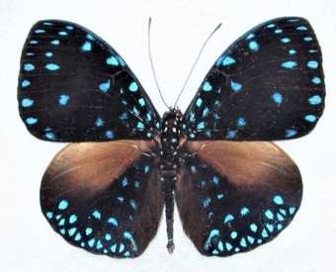

Blue Mountain Glory

- Blue Mountain Glory, Papilio ulysses ulysses, Indonesia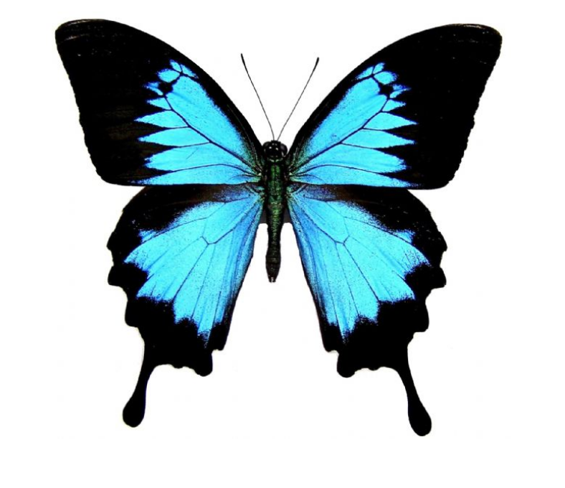

Second Chances/Metamorphosis

- Monarch Butterfly, Danaus plexippus, South America

Secret Poem (Chinese Emperor)

- Large Striped Swordtail, Graphium antheus, Africa
- Red Orange Ablatross, Appias nero, Indonesia
- Great Purple Emporer, Sasakia charonda, China
- Leprieur’s Glory, Asterope leprieuri, Peru

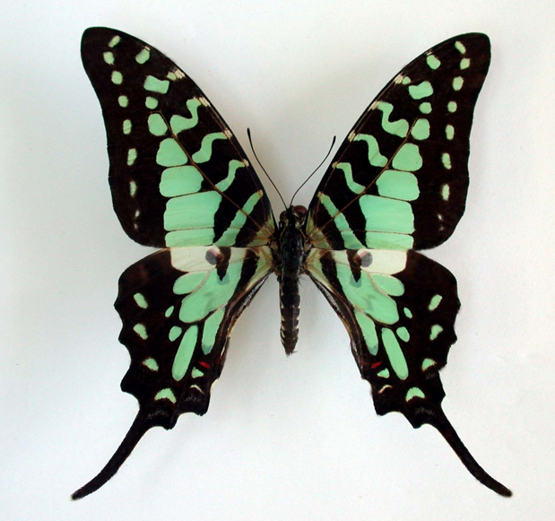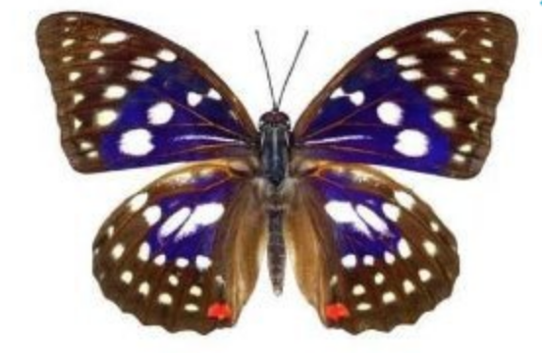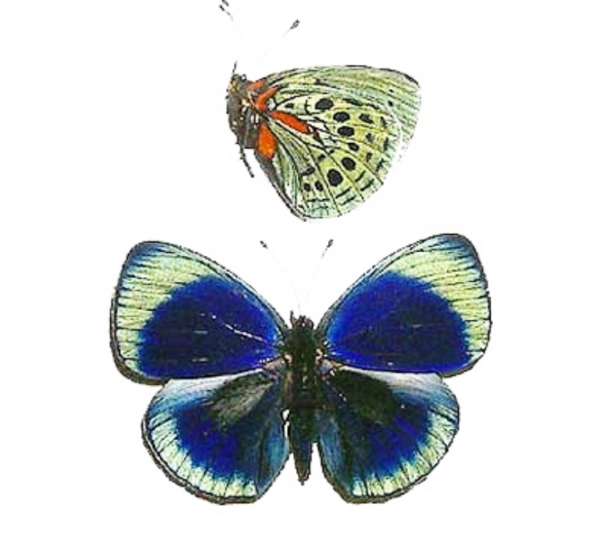

Entourage

- Phillipine Butterfly, Paranticopsis idaeoides, Phillipines
- Pink Glasswing butterfly/The Blushing Phantom, Cithaerius merolin, S. America

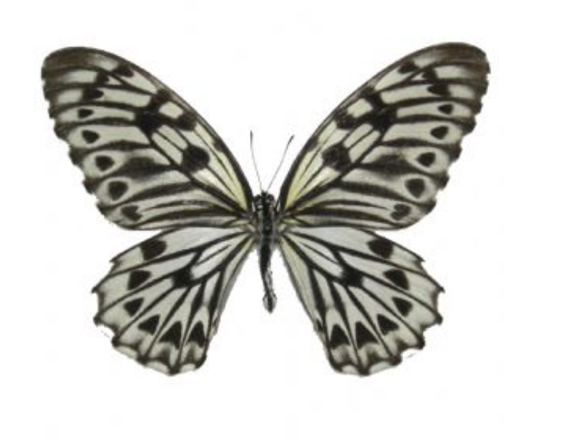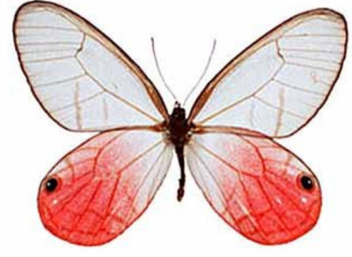
Sunshine Blue

- Orange Barred Sulfur, Phoebis philea, Florida
- Blue Mountain Glory, Papilio ulysses ulysses, Indonesia

Pink Sand

- Alpais Shining Purplewing, Eunica Alpais, Peru
- The Painted Beauty, Batesia hypochlora verso, Peru
- Sky Blue Morpho, Morpho menelaus menelaus, Guyana
- Blue Buckeye, Precis rhadama, Africa

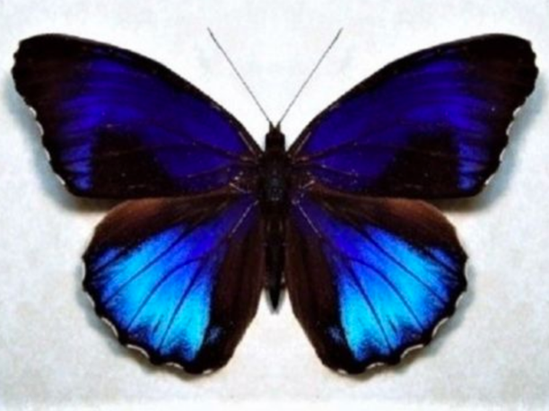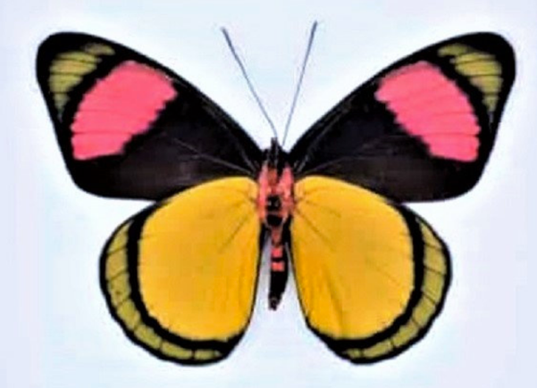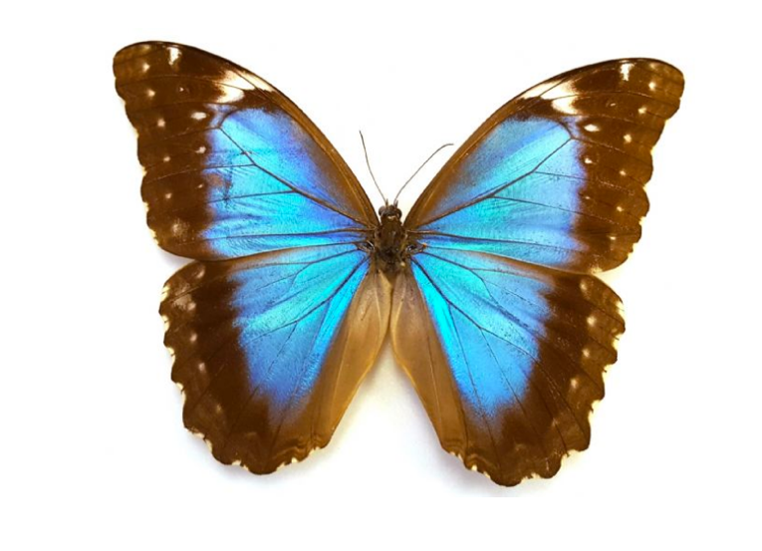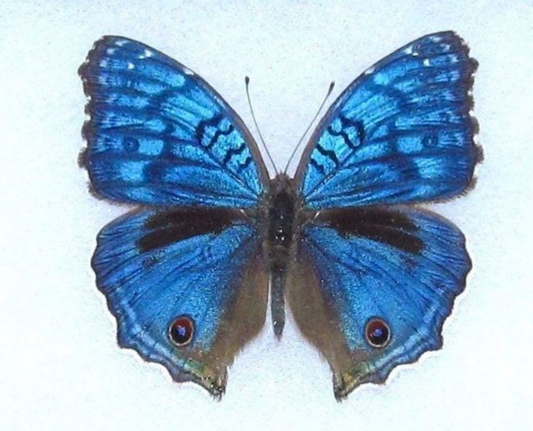

Window into Beauty

- Red Glider, African Cymothoe Sangaris, Africa

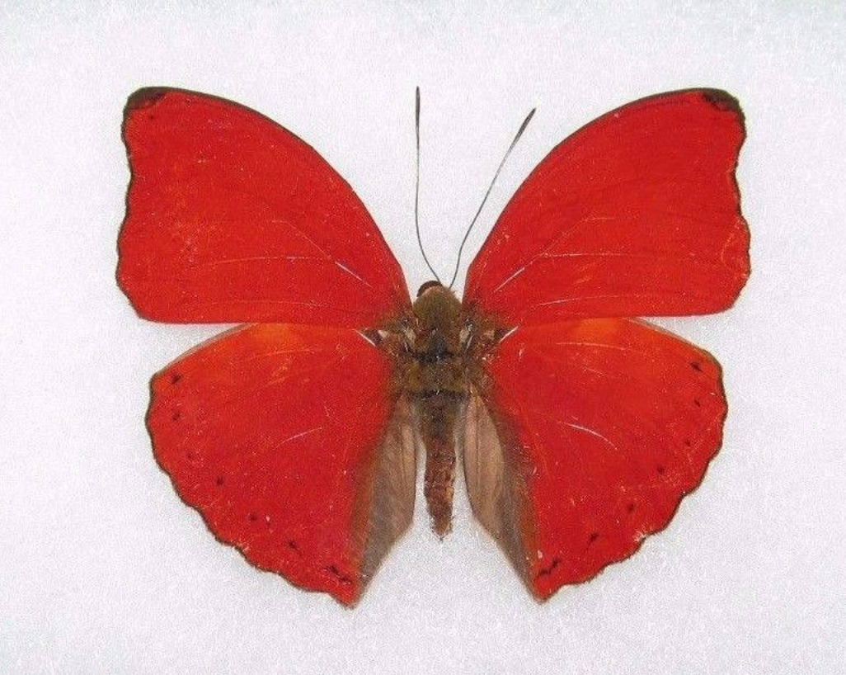

My Favorite

- Violet Washed Charaxes, Charaxes lucretius, Republic of Congo

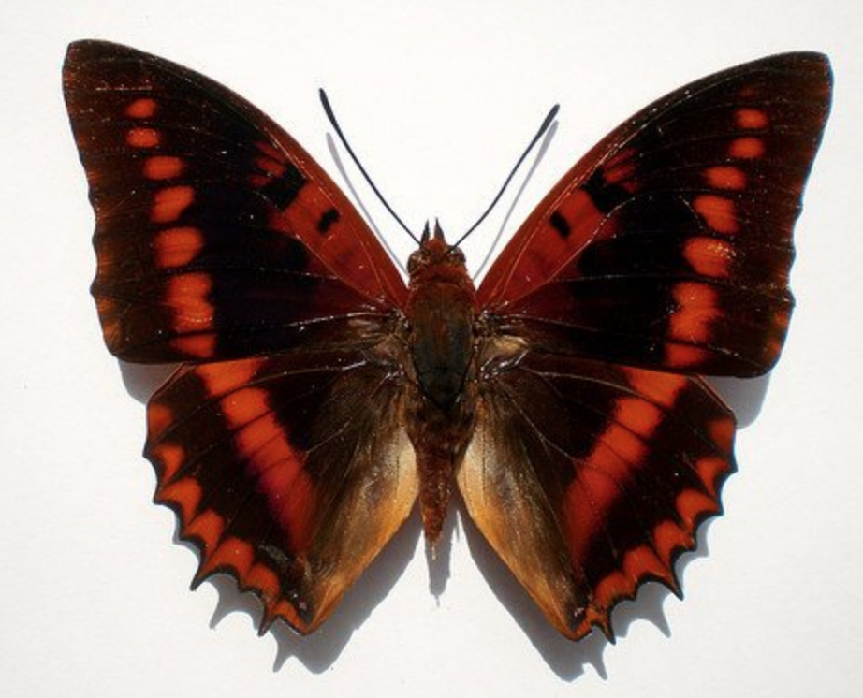

Intoxicated Garden

- Eastern Yelow Tiger Swallowtail, Papilio glaucus tiger, N. America
- Large Striped Swordtail, Blue Green Graphium antheus, Africa
- Red Orange Ablatross, Appias nero, Indonesia

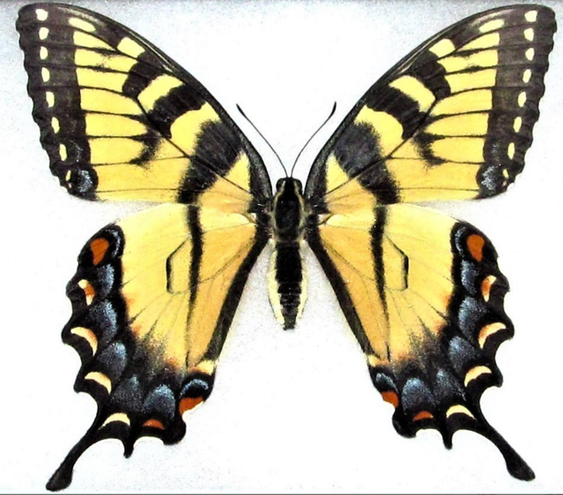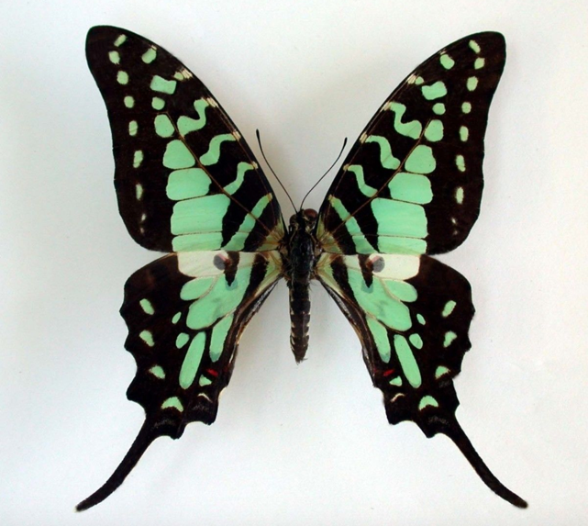

The Autumnal Monarchs

- Monarch Butterfly, Danaus plexippus, S. America

